**Create the data model**

i) To start the data modeler go to General settings 🡪 Configuration Workbench

ii) To start the configuration workbench, Choose the ZA data model

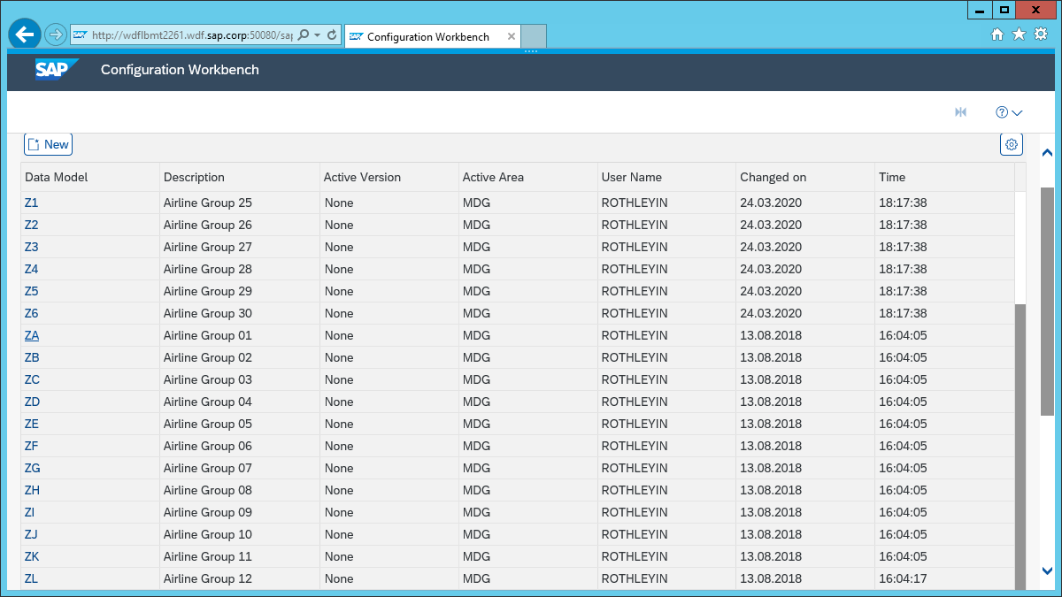

**iii)** Select the edit mode

**Define Entity type Airline**

Make it changeable via Change Requests and generate a data base table for it.

Validity for editions is not needed.

The identification is defined with the data element S_CARR_ID.

Hierarchies are not needed.

A text with length of 20 characters shall not be language dependent. (use “Medium text”)

The description should be “Airline”.

i) See the empty list on the left and choose new 🡪 In the general section now enter the details as below

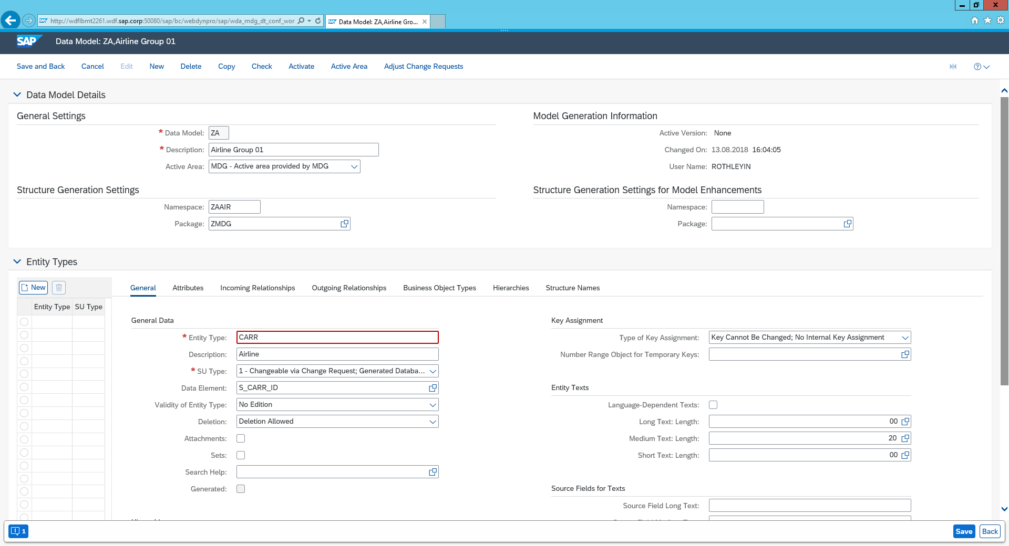

ii) Select the tab Attributes🡪 Chose new 🡪 Enter the details as below

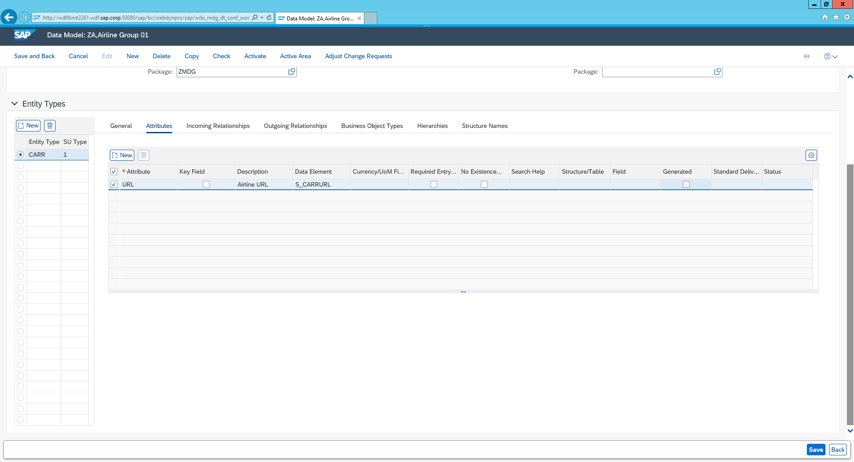

iii) Choose save and create a new transport request 🡪 Insert the short description as follows ‘Group 01 – create new data Model ZA & Process’

**Define entity type Currency**

i) Select the general tab and create a new entity type 3 for currency using data element S_CURRCODE. (Enter details as below)

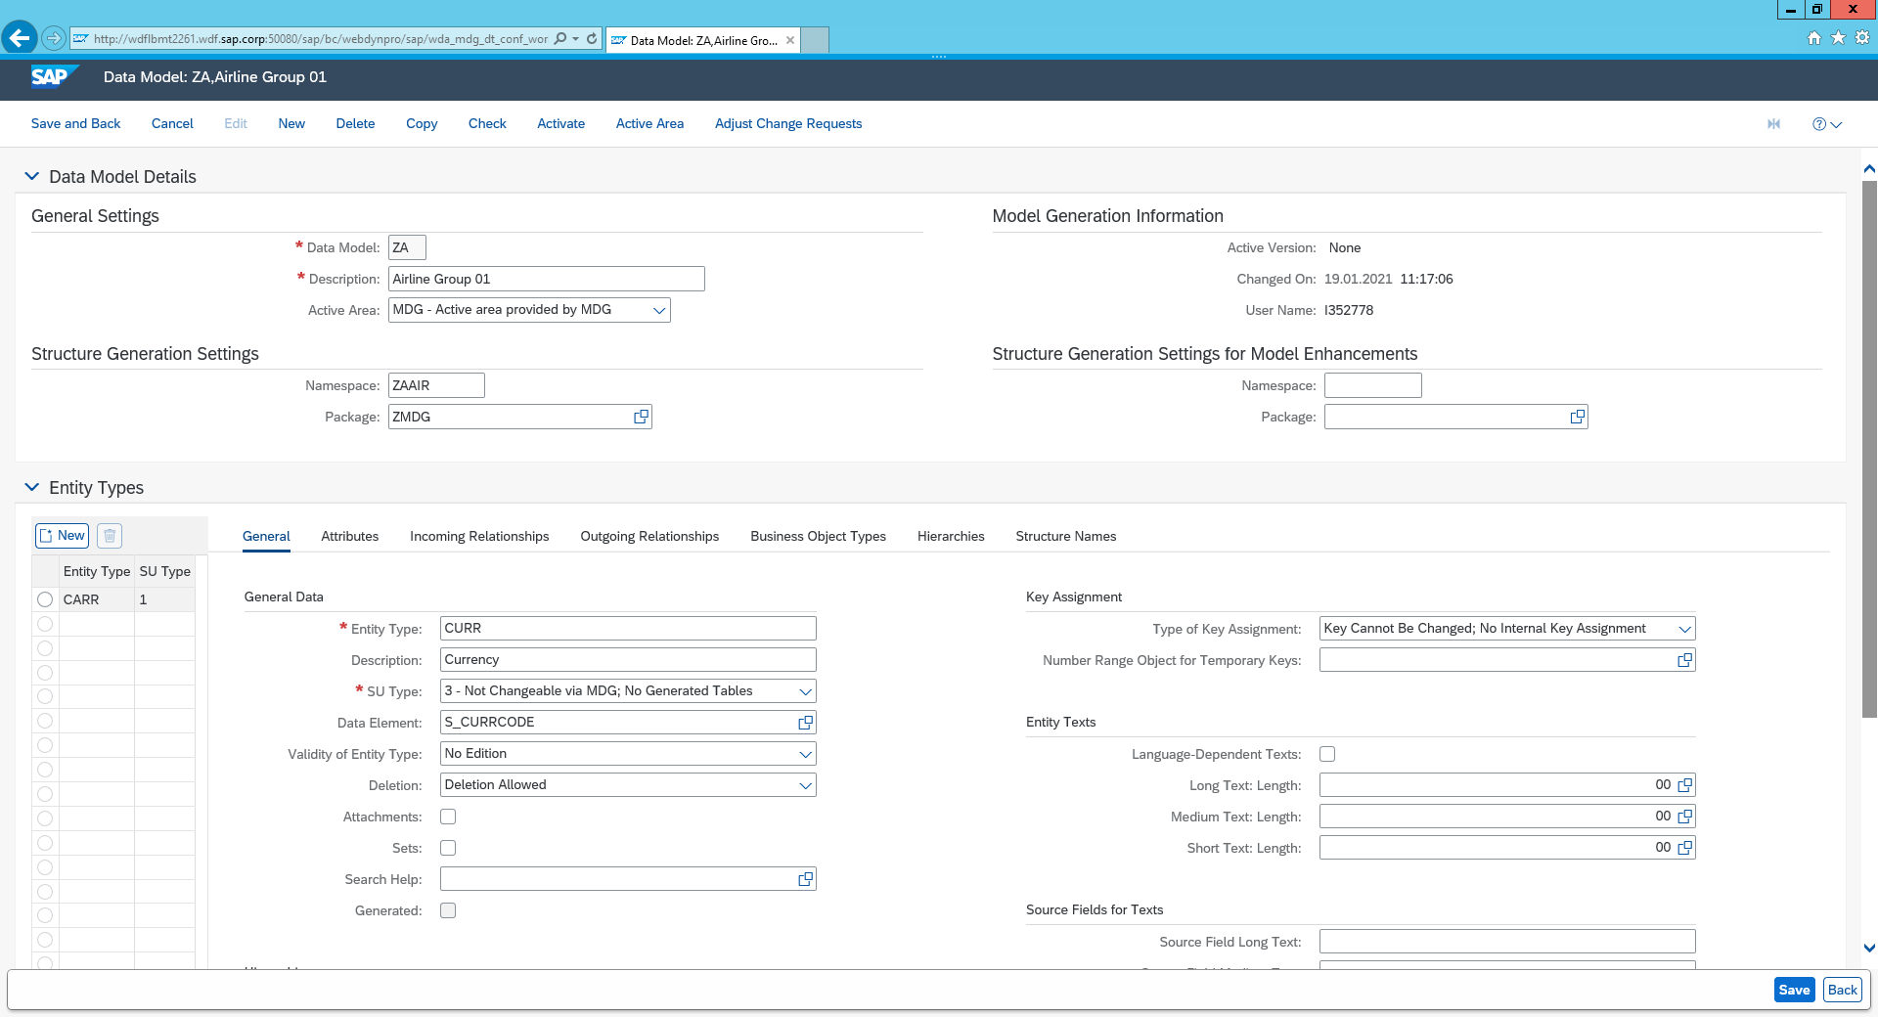

ii) Select outgoing relationships 🡪 select New 🡪 enter reference 1:N relationship

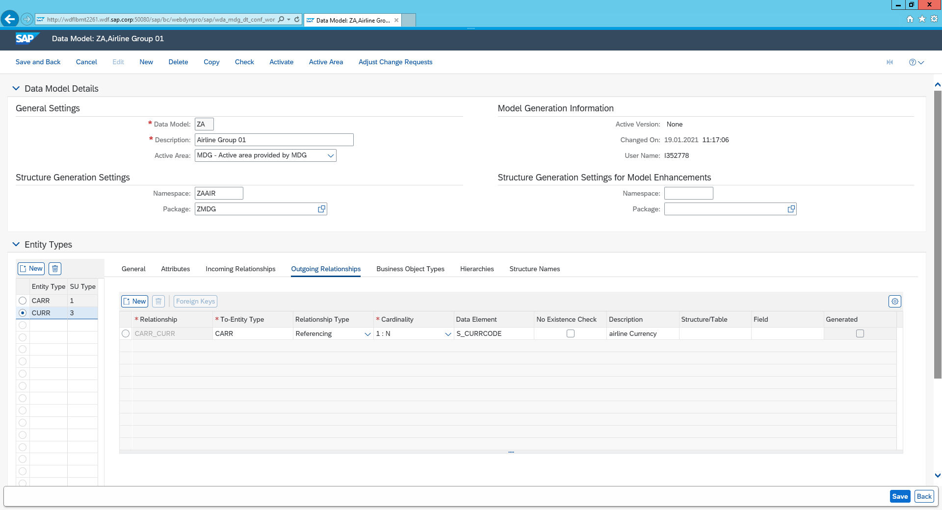

Activate and display

i) Select Check – you can ignore the errors on “no change documents”. Then Save and Activate. If the system prompts for a Workbench Request, create a new one or select any existing request of your own requests.

ii) To display The data model go to the SAP Easy Access Screen and enter transaction SA38

iii)Enter USMD_DISPLAY_DATA_MDOEL 🡪 Click Execute

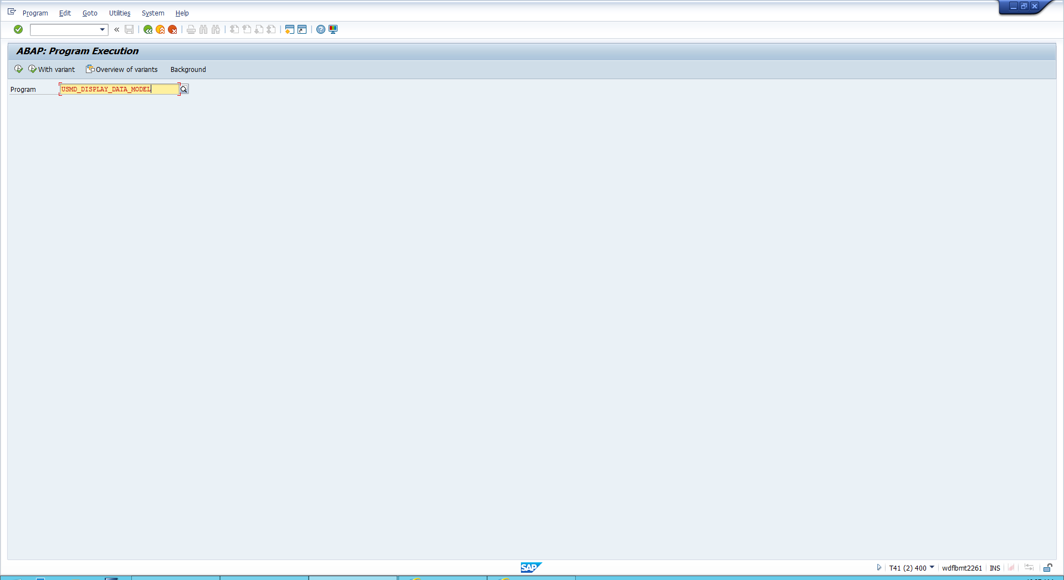

Iv) Enter the name of your data model ‘ZA’ and click enter

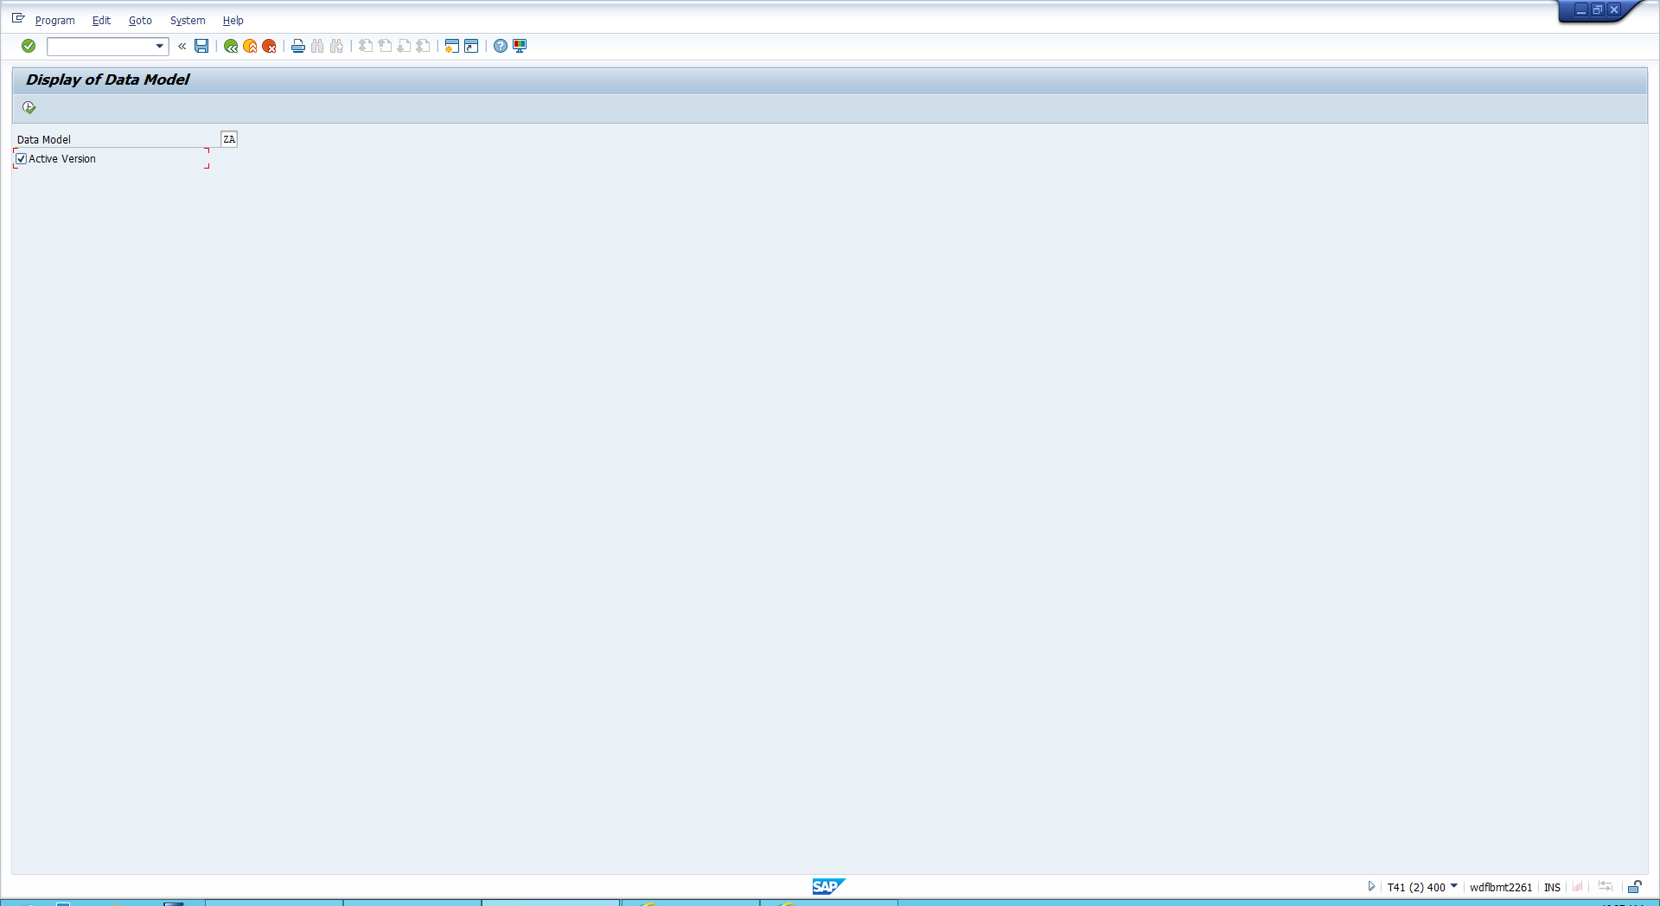

You will now see the Data model

V) To display the MDG Tables 🡪 Go back and enter USMD_DATA_MODEL 🡪 Then select ZA and count data Records

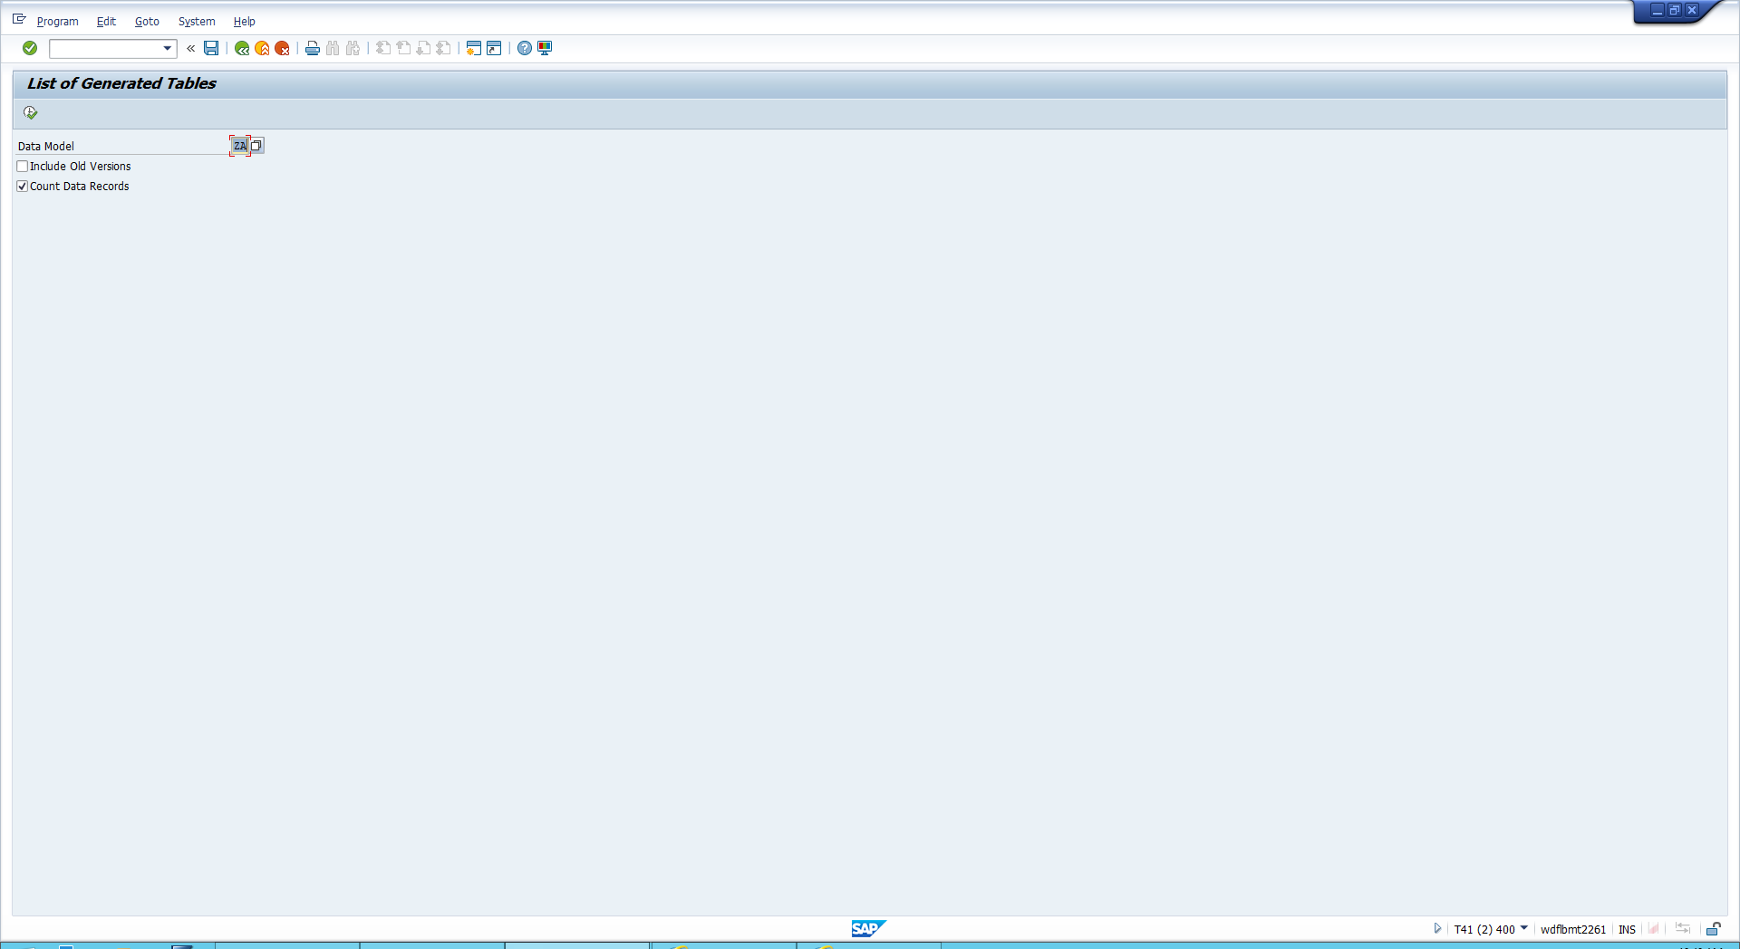

vii) Double click the first line to see the structure details

Using the data model id and the Entity Type ID, you can see your key field that has been assembled. You can see the attribute ‘URL’ as well as the currency that is brought in via the 1:N relationship

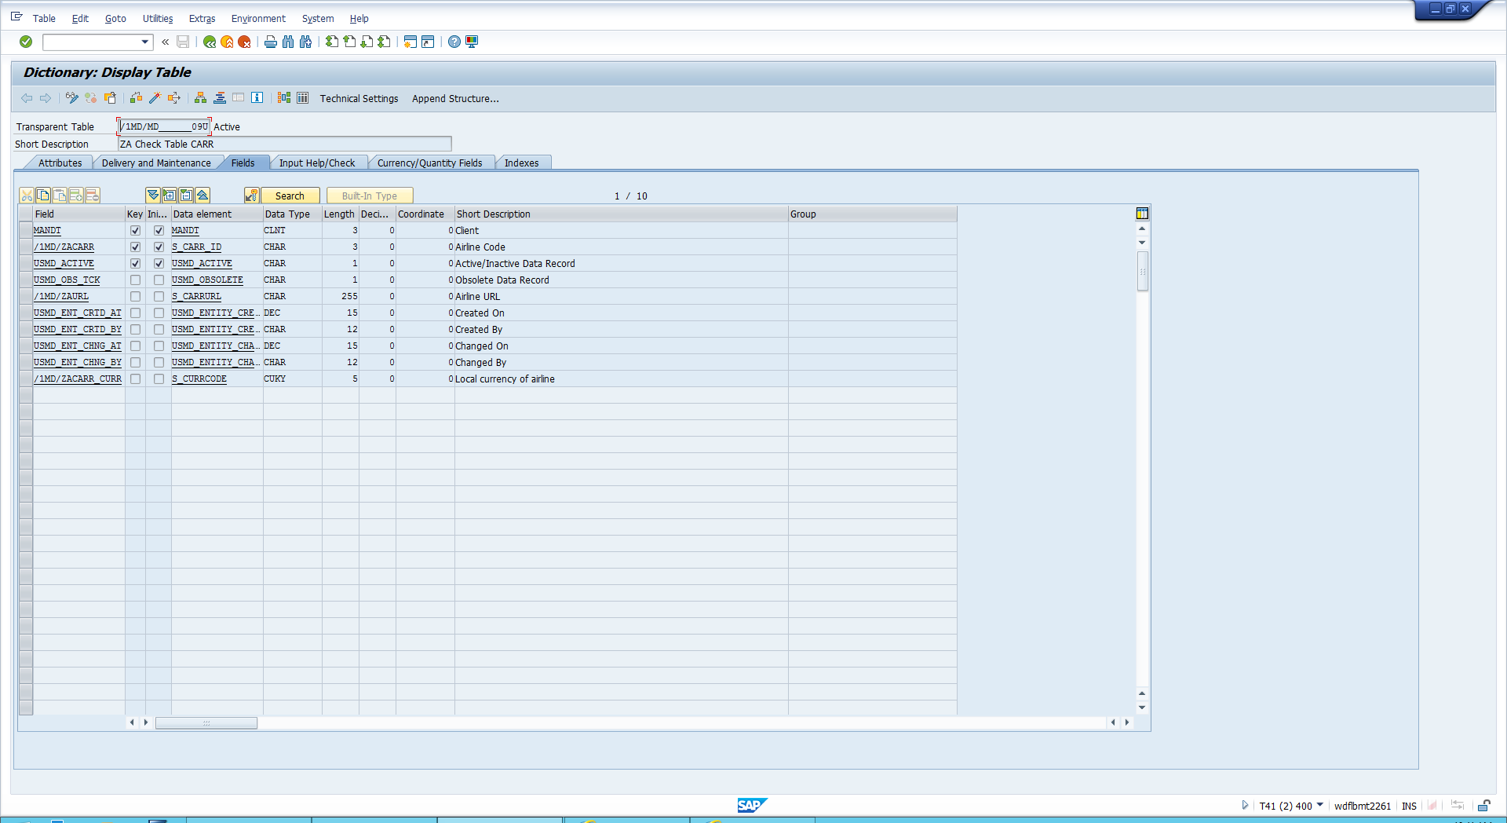

**Create the UI configuration**

Create configuration

i) mdgimg 🡪 General Settings 🡪 UI Modelling 🡪 Manage UI Configurations

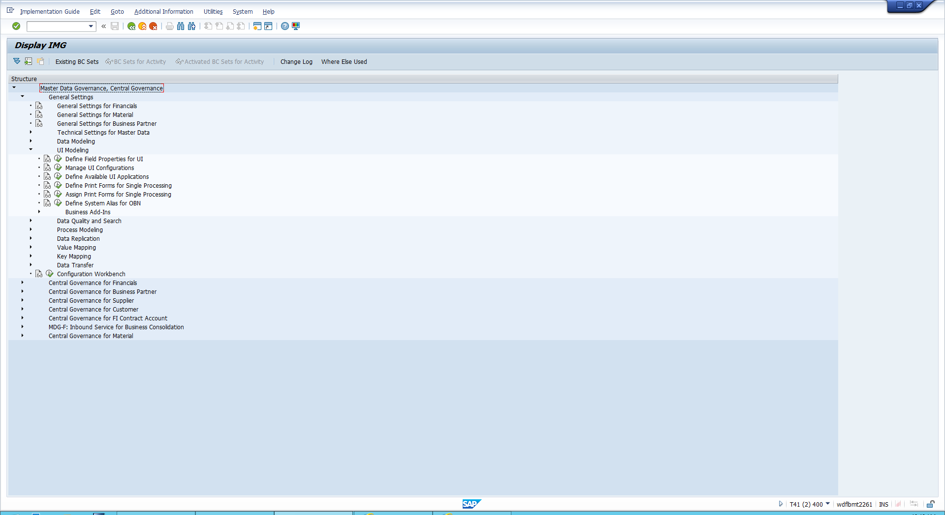

ii) here you will need to find the USMD_ENTITY_VALUE2 option 🡪 Select it 🡪 and click copy

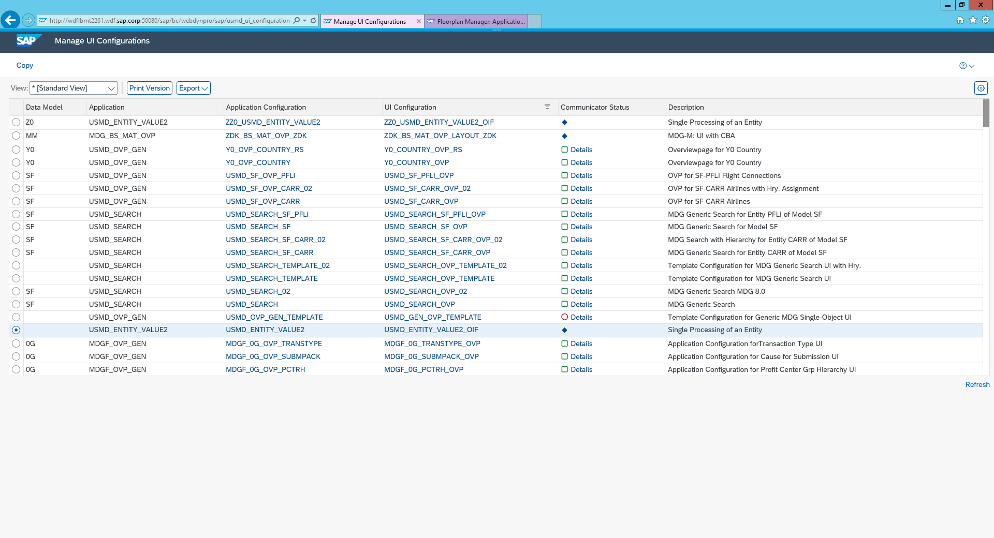

iii) Now we have to adapt the configuration ID’s 🡪 Choose Change Affixes Up the top

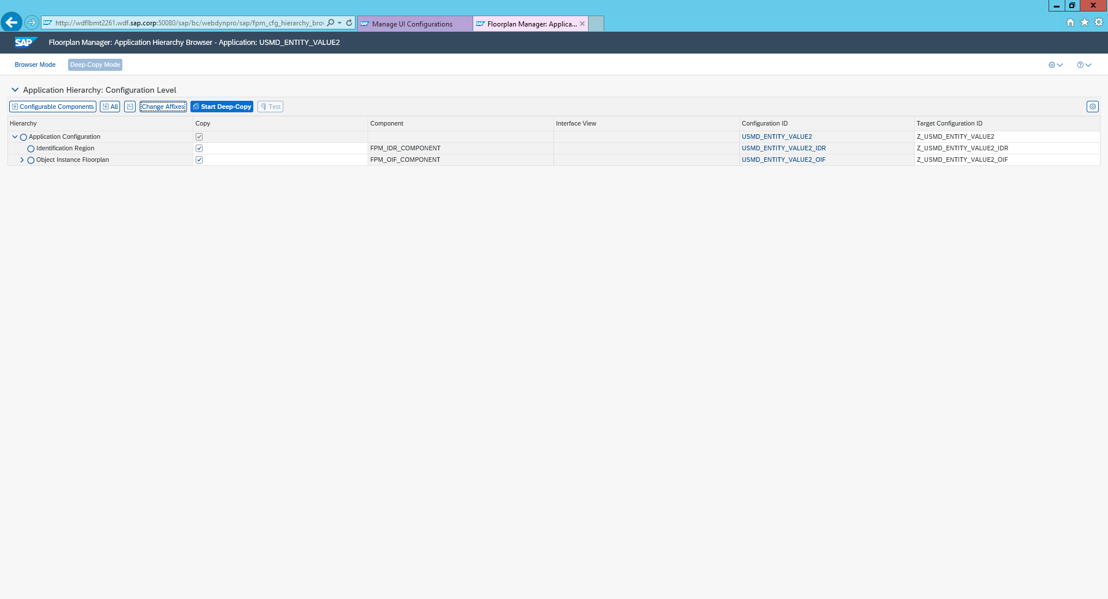

iv) Change Affixes. According to the naming convention, change the value for the prefix to Z##. Remove the value for the suffix

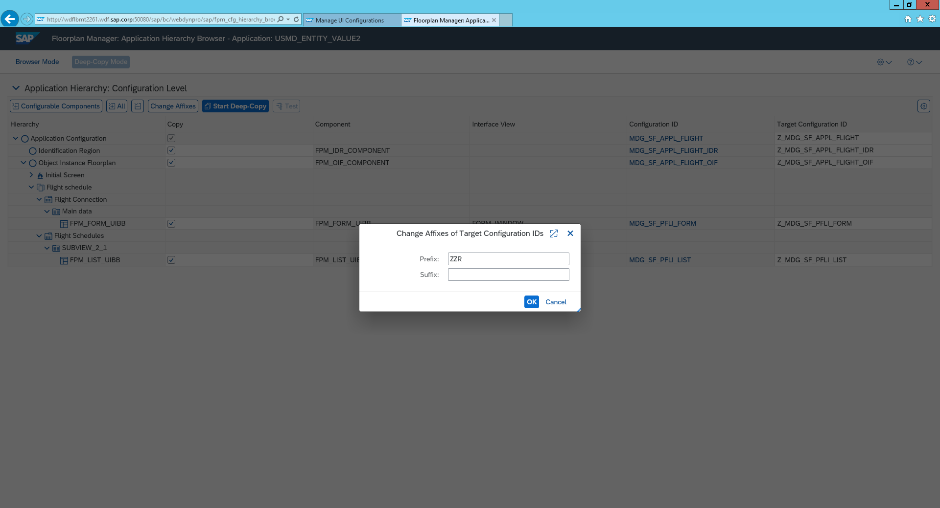

v) Verify the new values for the target configuration IDs

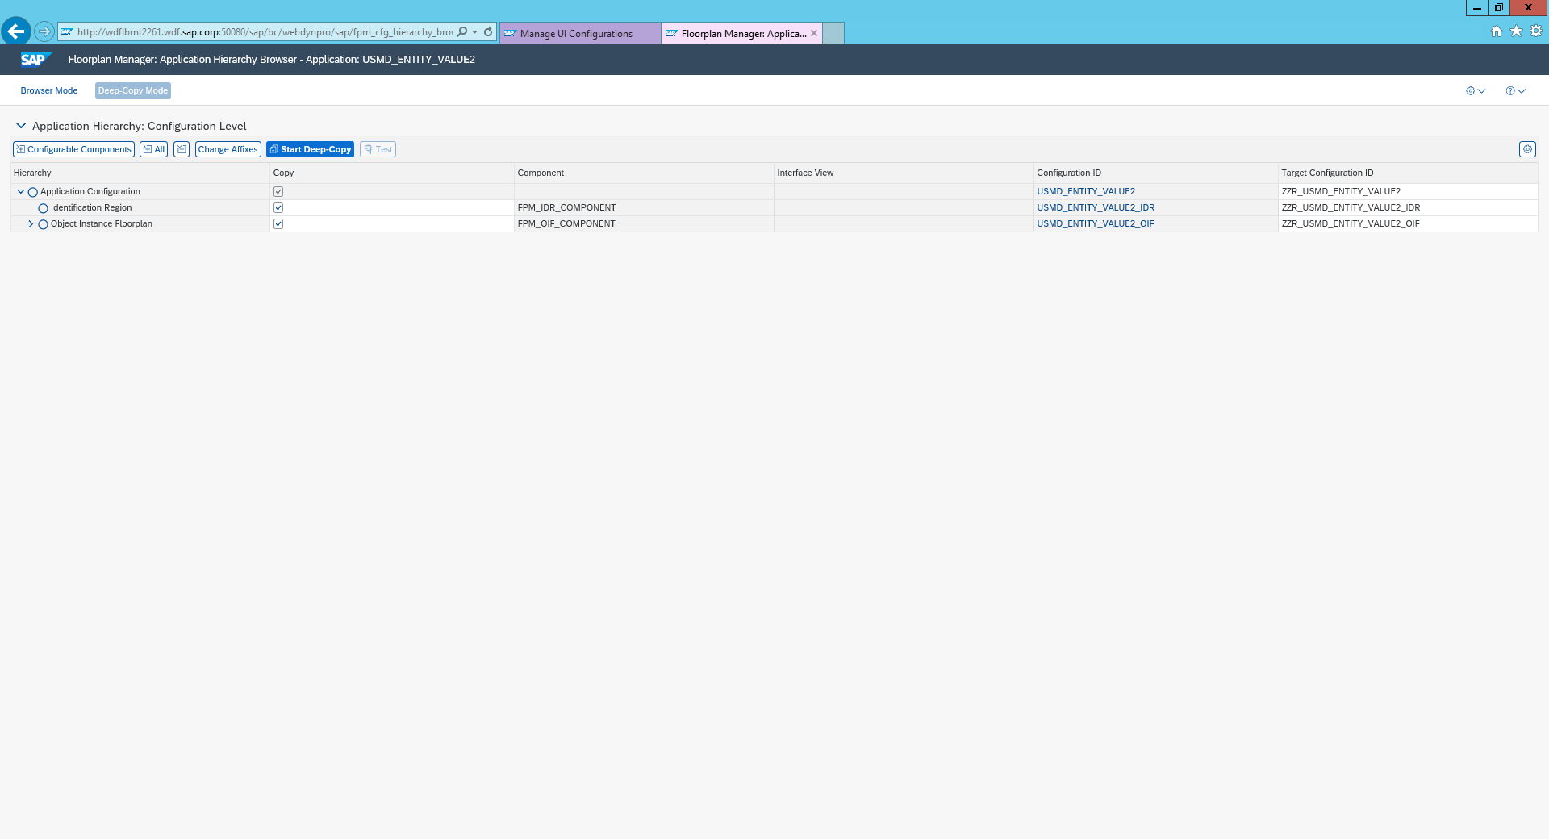

vi)Choose Start Deep copy at the top -> Select local object button

Assign your Configuration to your data Model ZA

i) Navigate to new Application Configuration by double clicking on ZZR_USMD_ENTITY_VALUE2

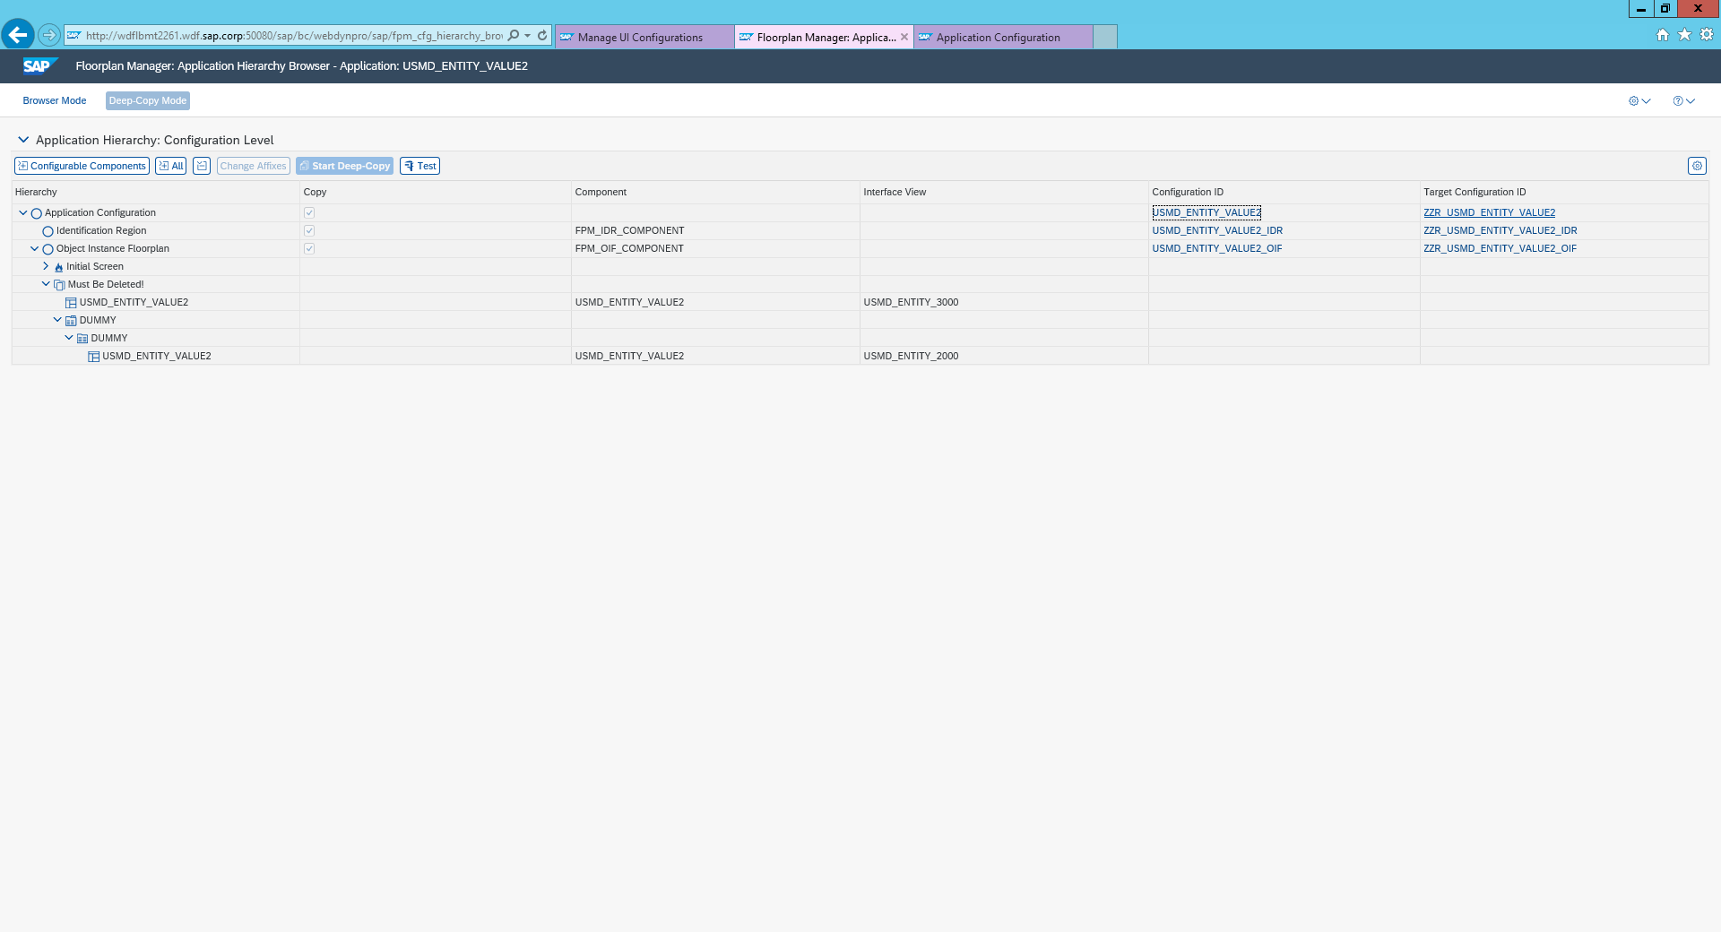

ii) Choose the configuration ID of the new application configuration that you copied

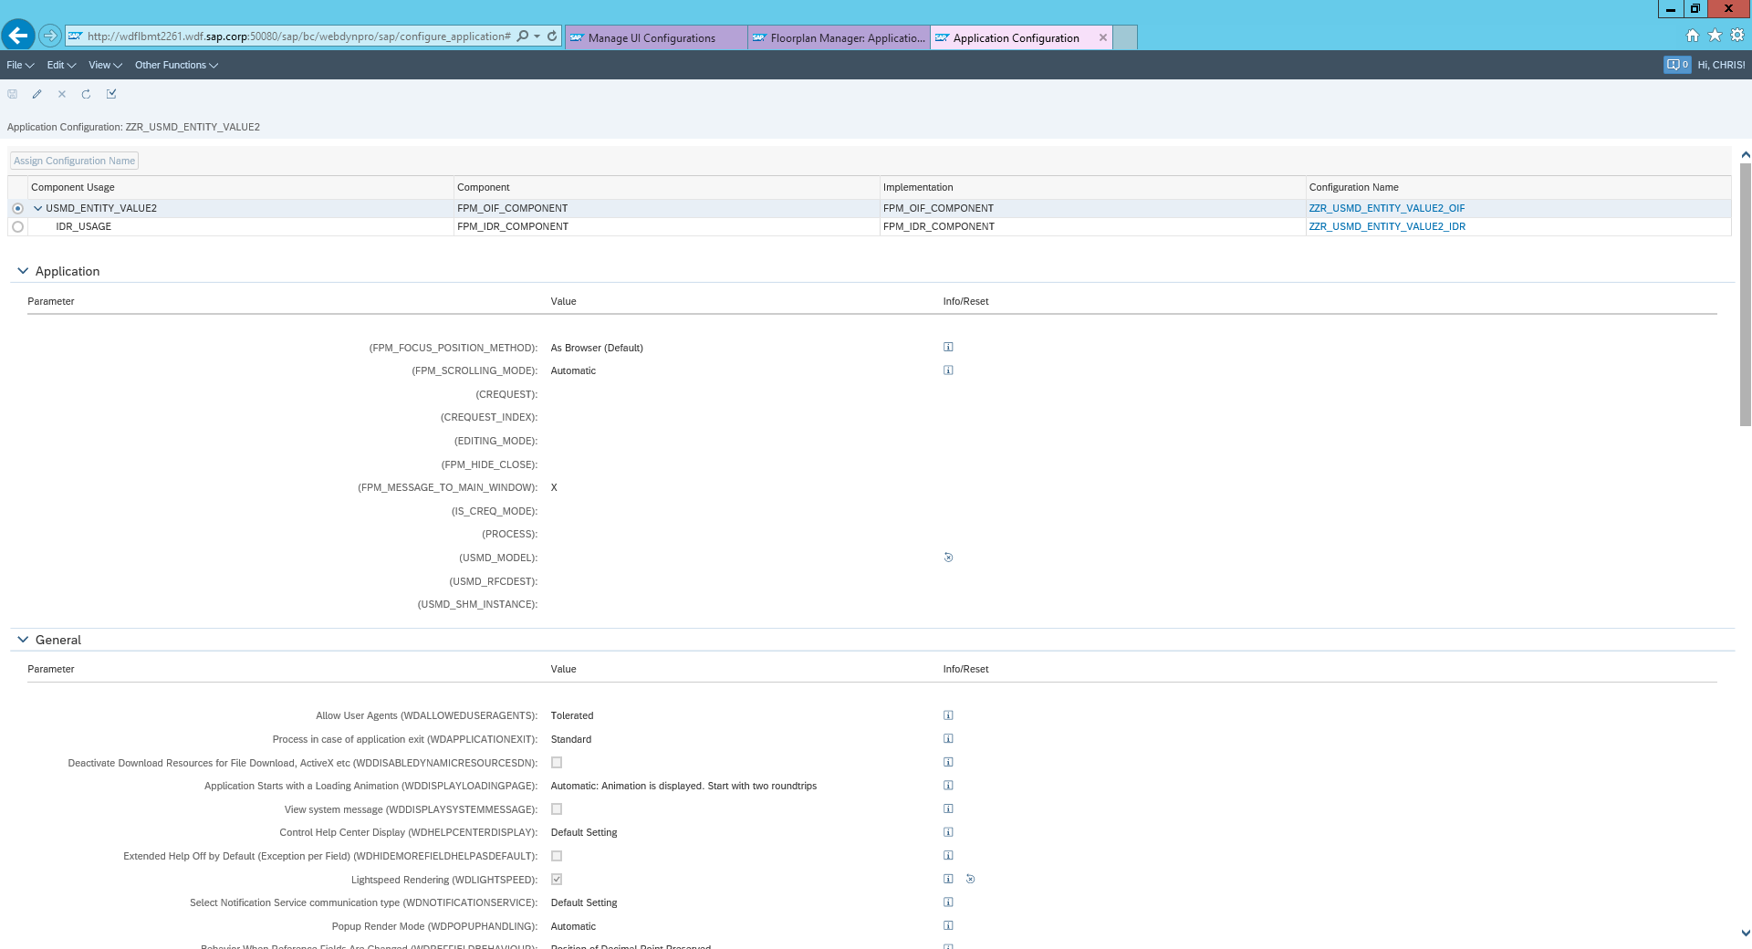

iii) Select the pencil in the left top corner (edit)

iv) In order to link your application configuration with your data model, enter the id of your data model for the parameter USMD_MODEL

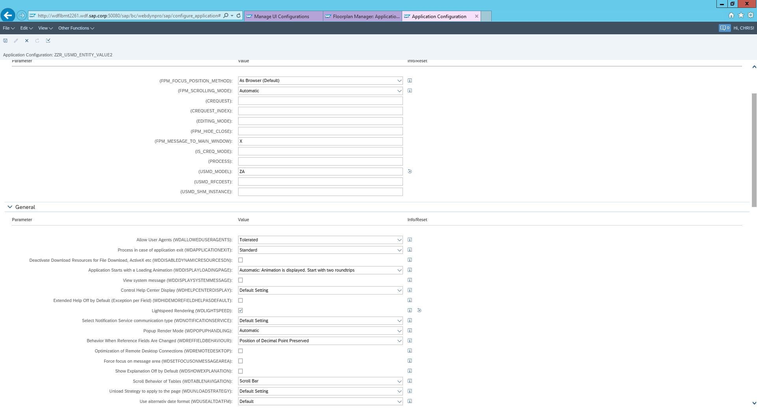

v) Save your changes

Define the form UIBB

i) Navigate to the OIF Configuration 🡪 Double click the configuration name you created ZZR_USMD_VALUE2_OIF

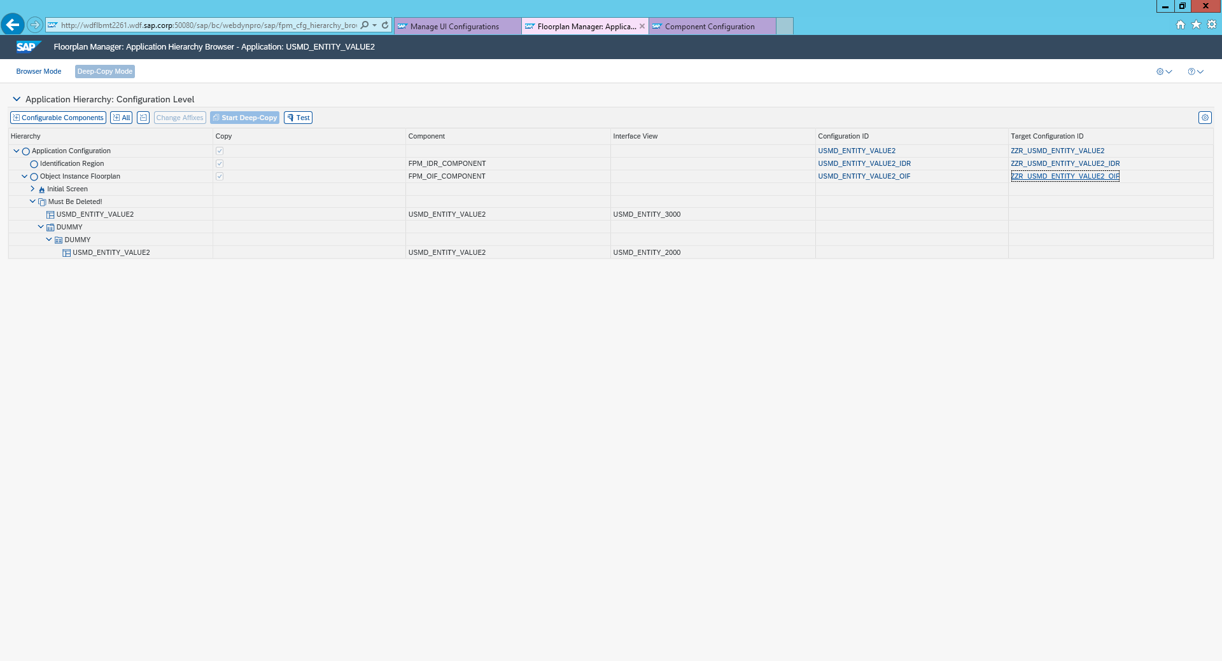

ii) Open the left panel if not already opened 🡪 Click the highlighted button below

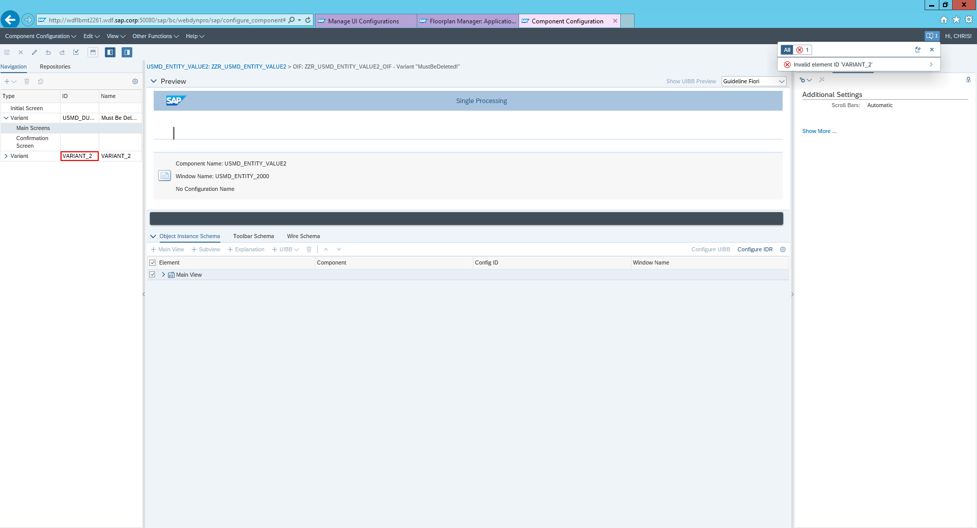

iii)Create a new variant by selecting edit (pencil) 🡪 then the plus 🡪 Then choose variant

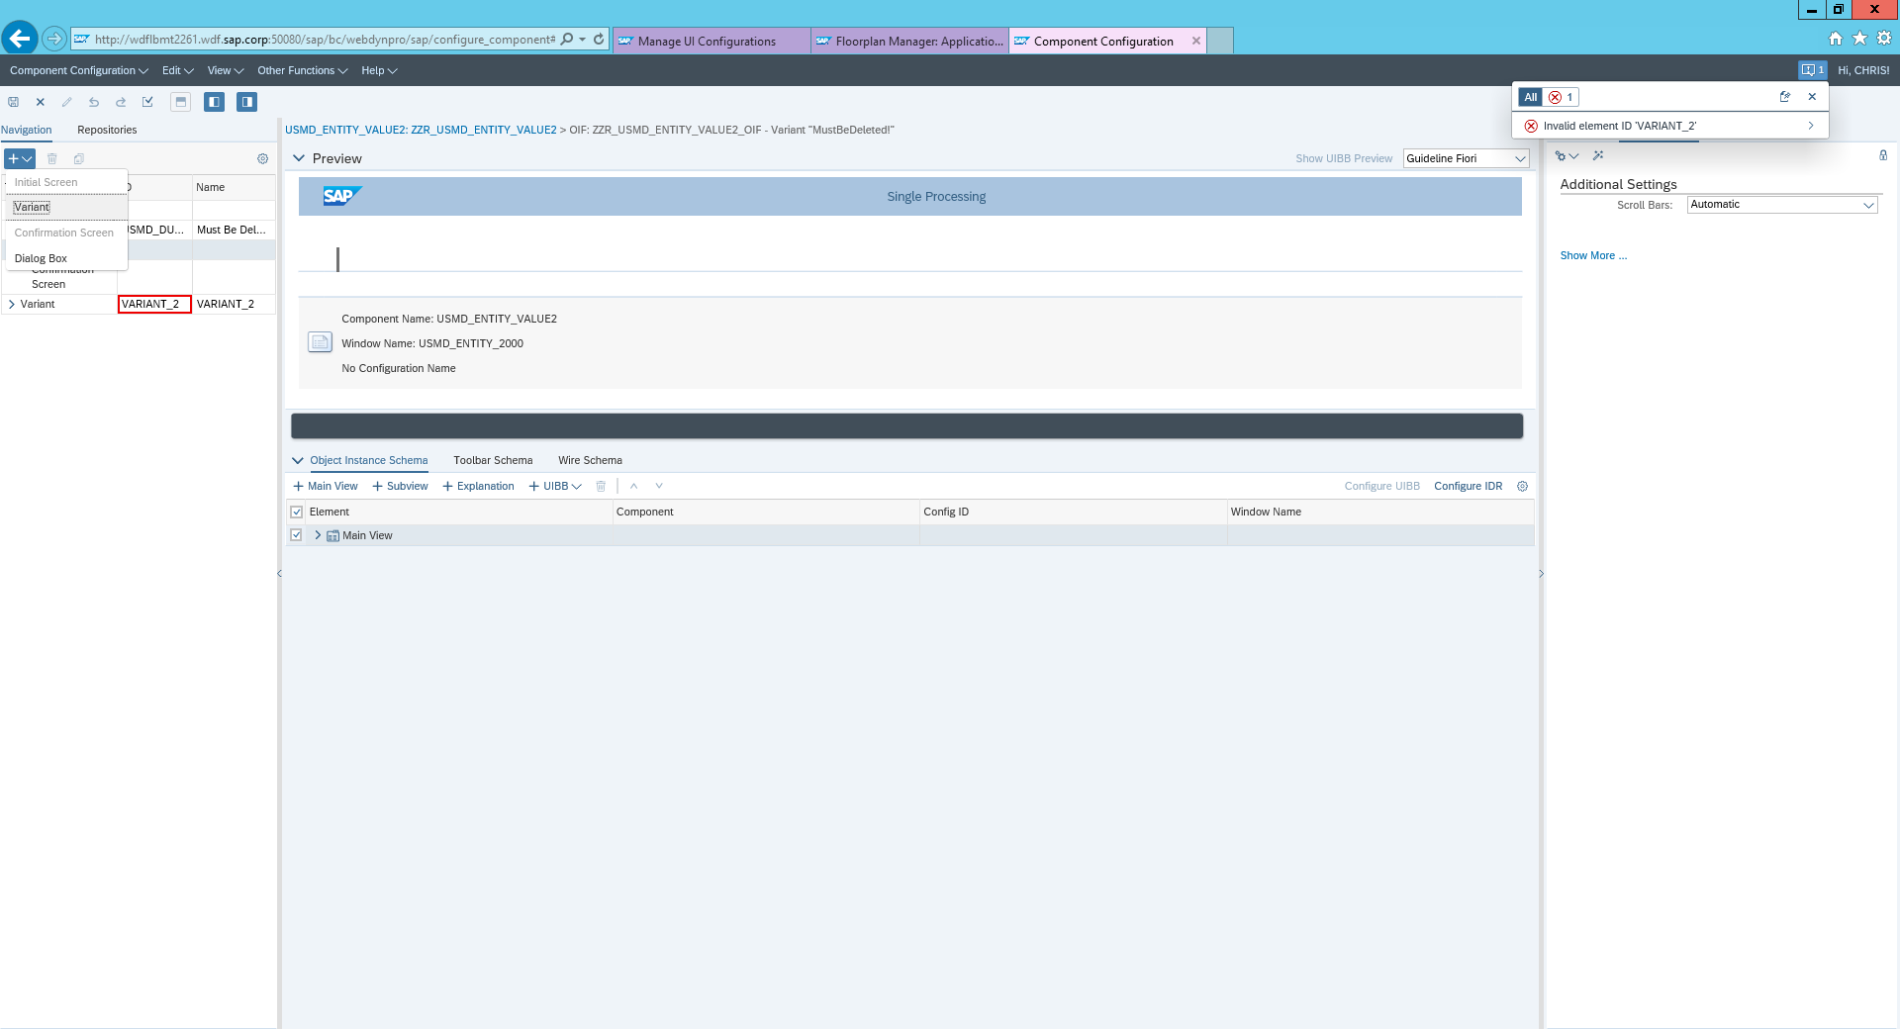

iv)You can enter the values in as follows:

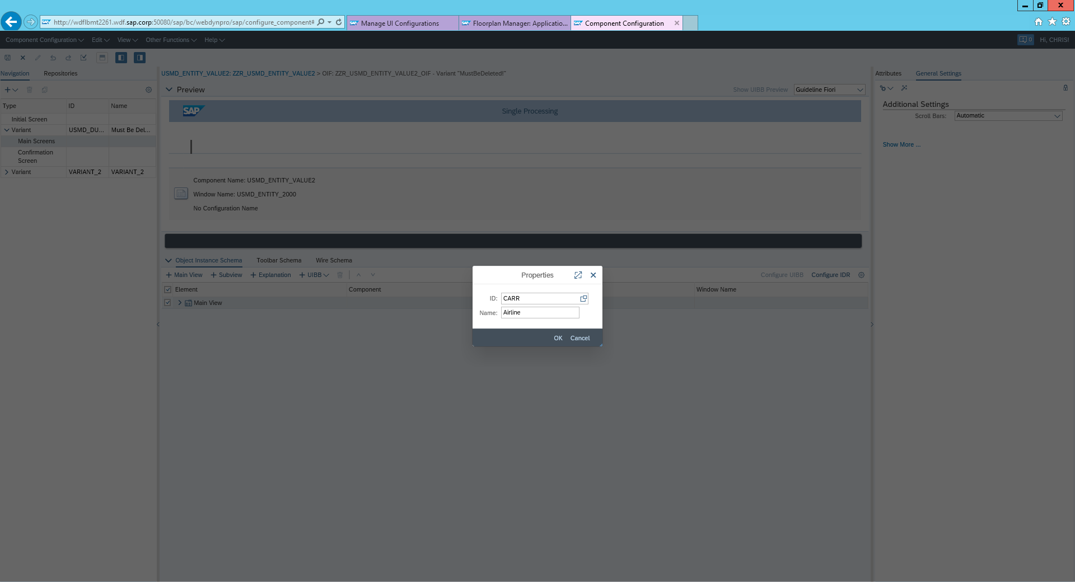

You should now be presented with three errors:

* Enter a valid Component for UIBB (Window Name)
* Enter a Valid Window name for UIBB
* Invalid element ID Variant 2

v) Locate to where these names need to be entered simply double click on them

vi) Change the values to as follows:

Component: FPM_FORM_UIBB

Configuration Name : Z 🡪 Your ID 🡪 Form_Airline

Window Name: FORM_WINDOW

Ignore the error that your config ID does not exist

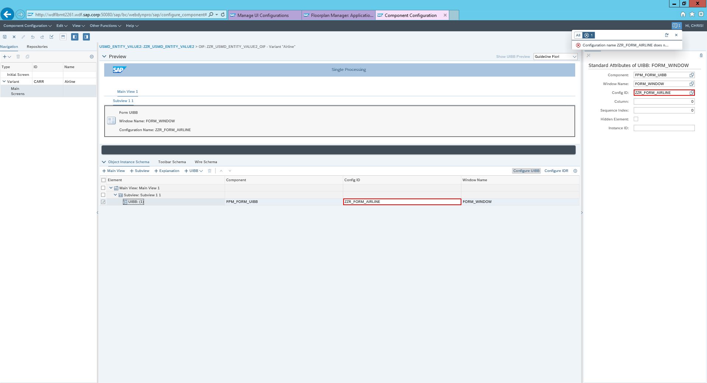

vii) You can now delete the other varians🡪 click on Variant USMD_DUMMY 🡪 Bin. Repeat this for Variant 2

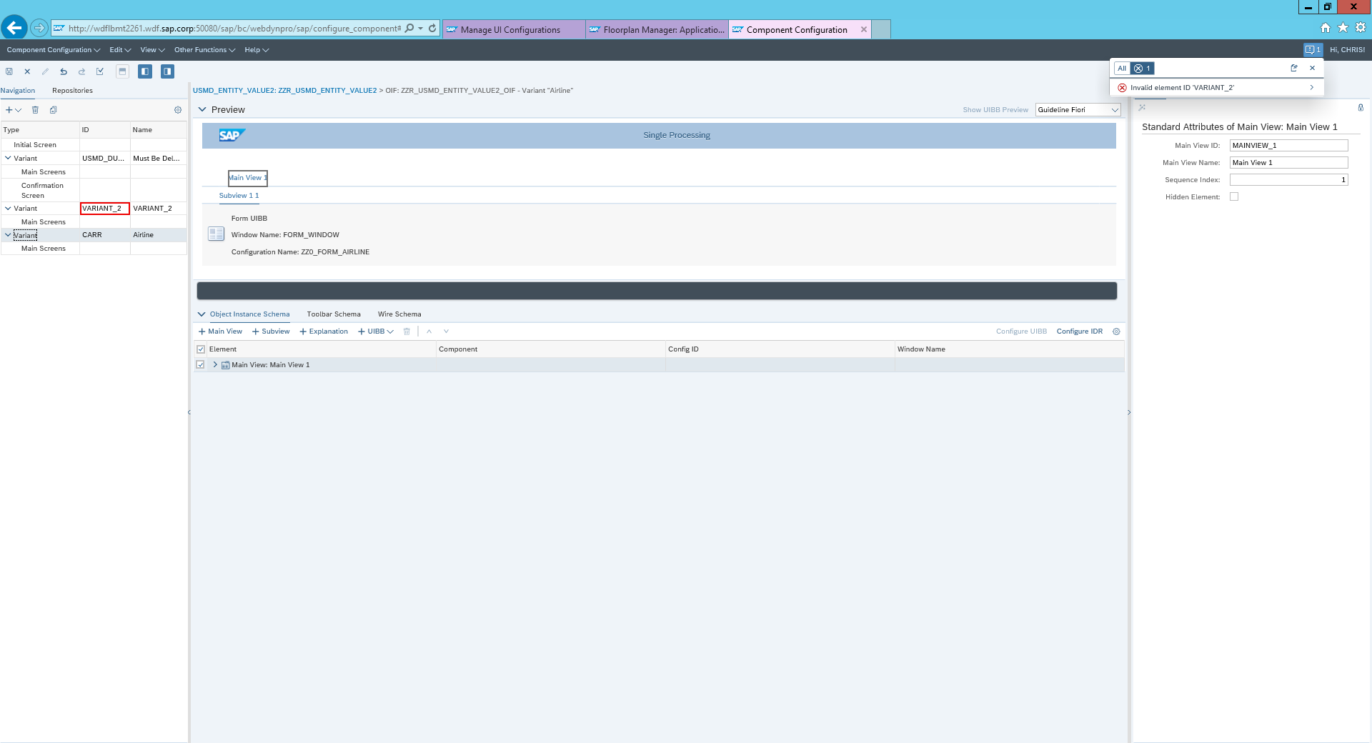

viii)Make sure to save the OIF Configuration

**Show a preview of UIBB**

i)To start the UIBB select your variant 🡪 locate to the sub View and click on the line previous edited 🡪 Click Configure UIBB

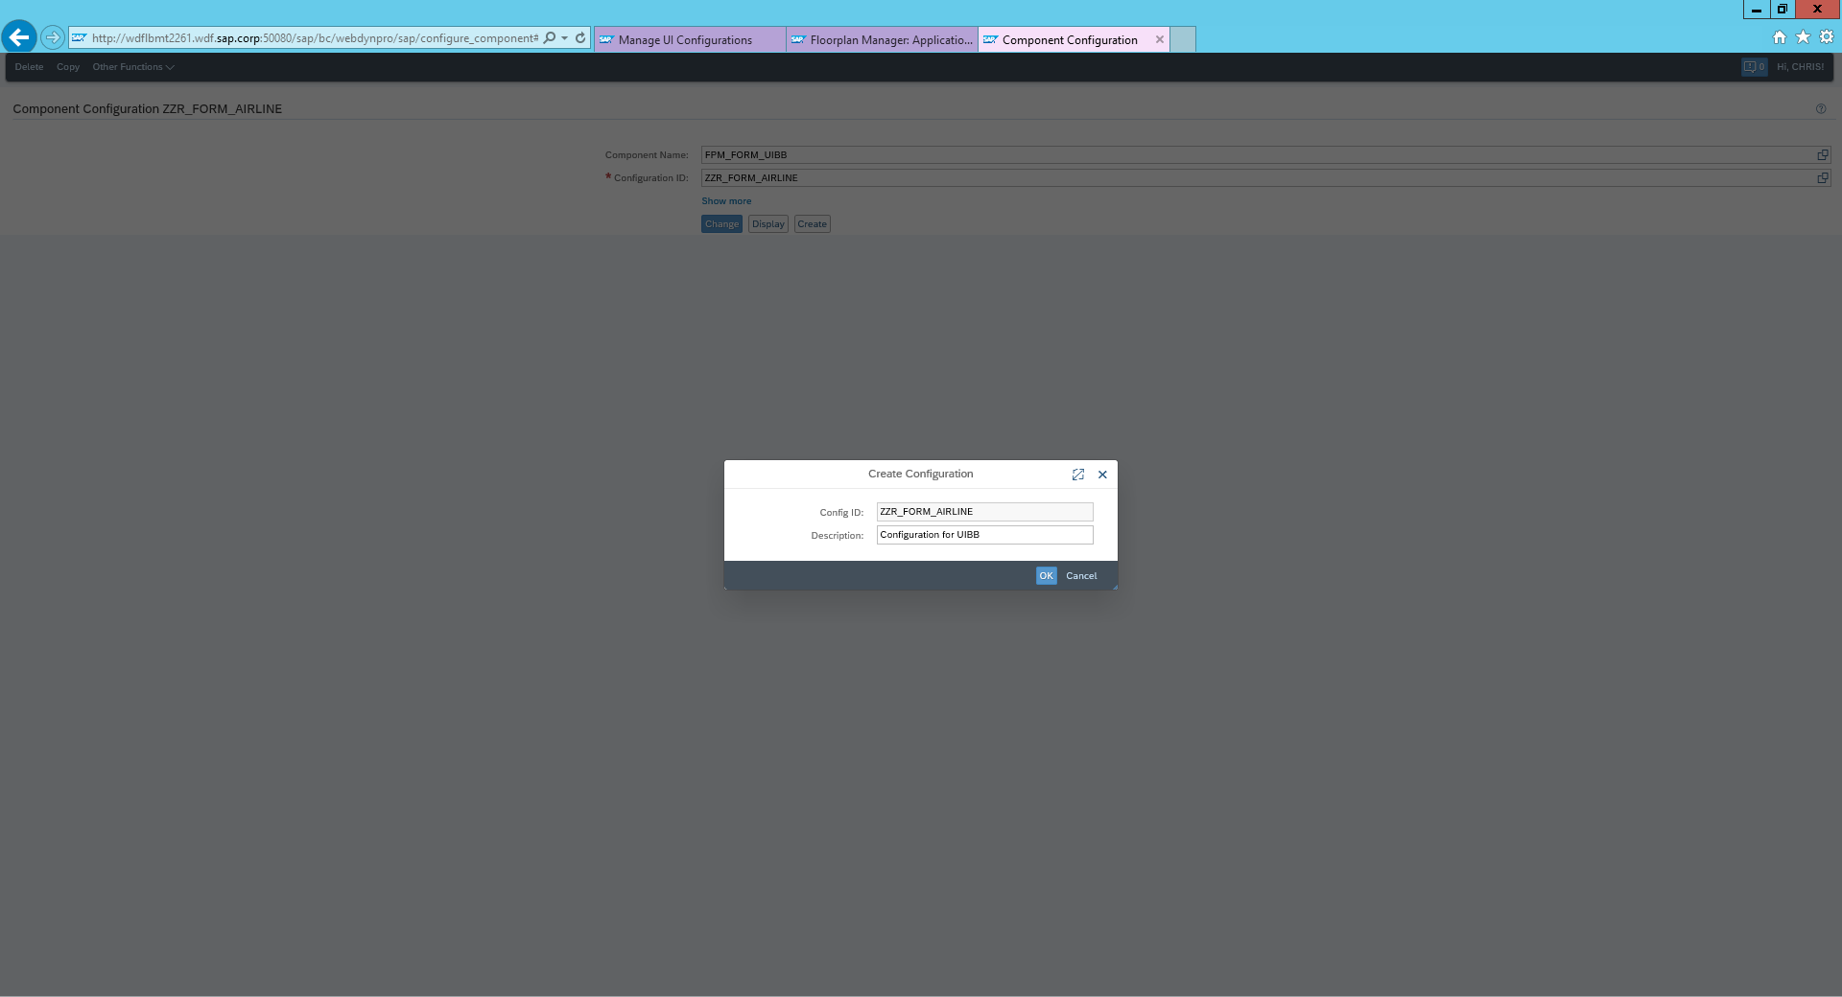

ii) In the description write Configuration for UIBB

iii) Select Local Object

iv)Select the Feeder class ‘CL_USD_ENTITY_VALUE2_PROXY’ 🡪 Click ok

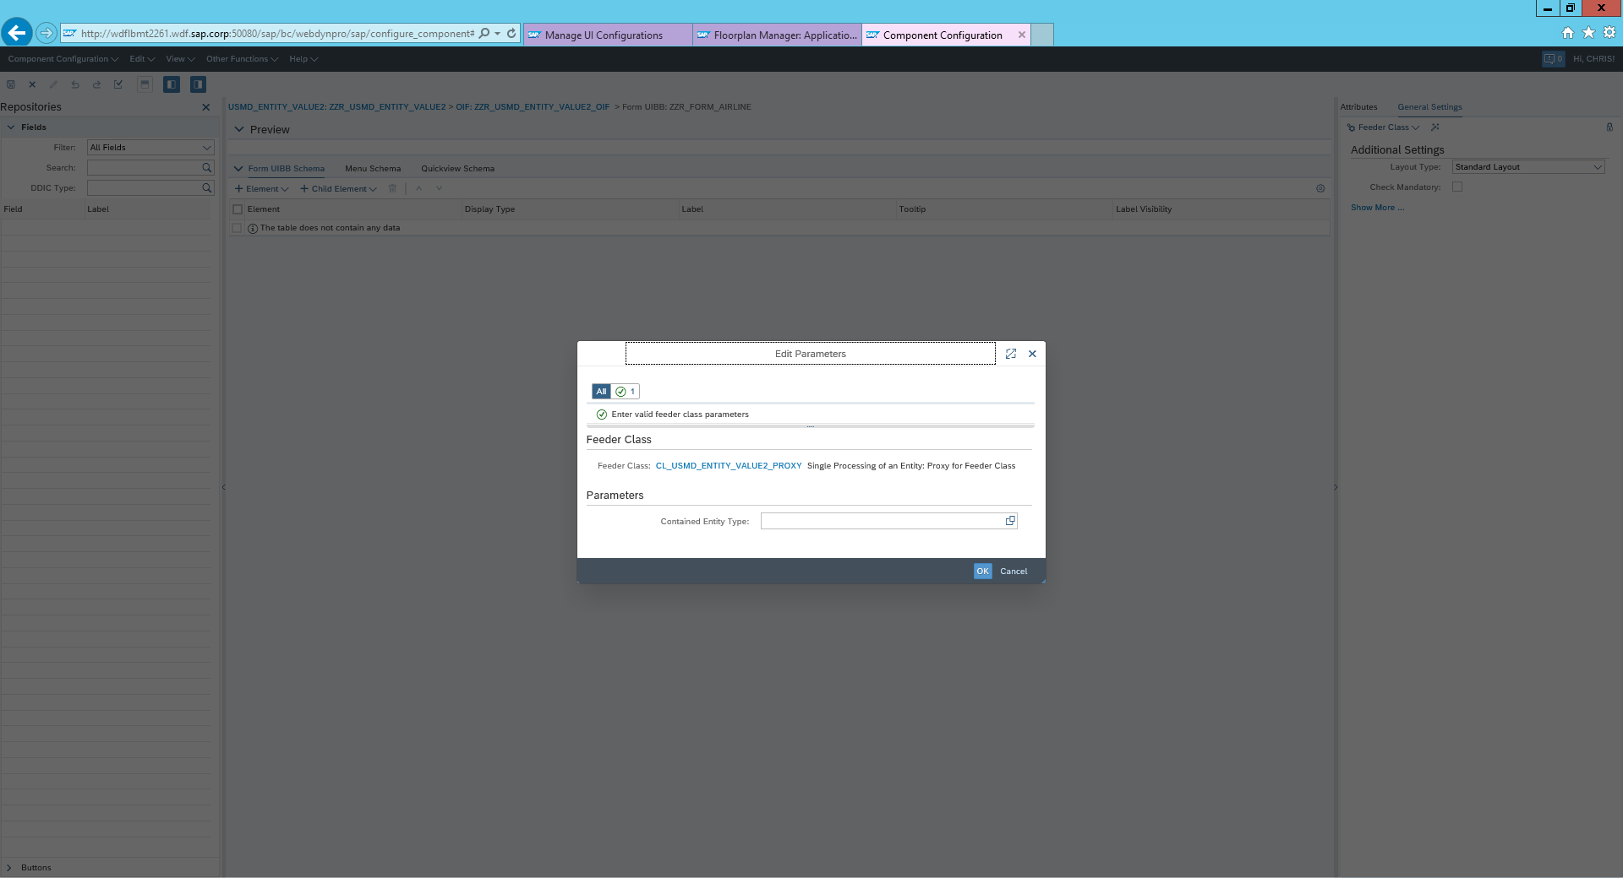

v) To add a new group, choose Element → Add Group.

This will allow you to add a new element for grouping the fields to be placed on the screen.

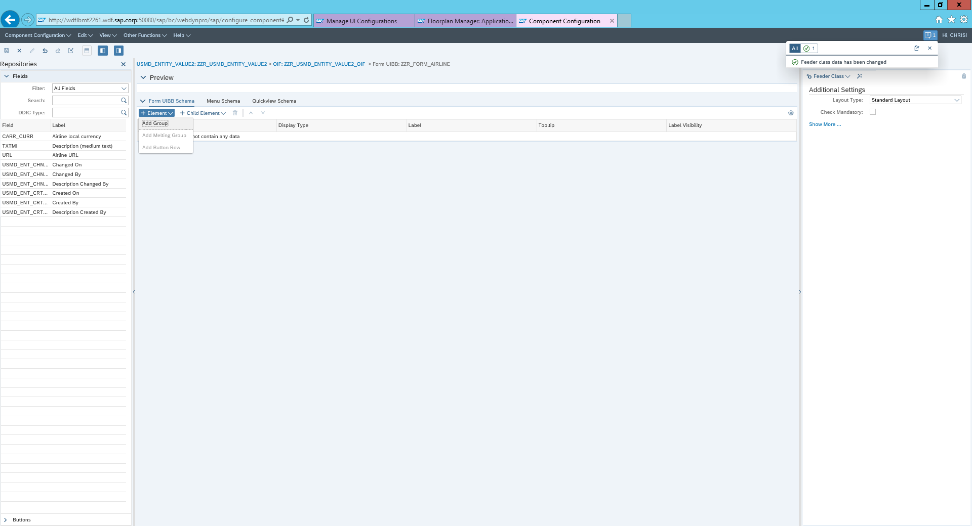

vi) To add elements to the group, while having the newly created group selected, choose Child Element → Add Elements to Group

vii) The system presents a list of attributes of the entity type. Select the fields defined in your data model: CARR_CURR, URL , TXTMI 🡪 Choose okay

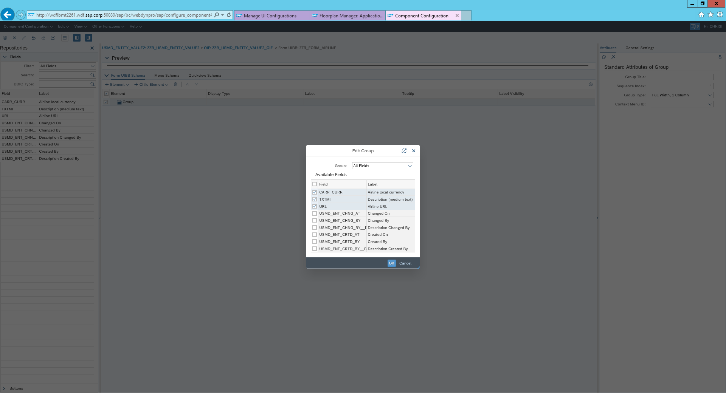

viii) To change the labels and further attributes of the fields, switch on the Attributes if not visible, and, for example, select the Element URL and reduce the UI Element Width to 30em.

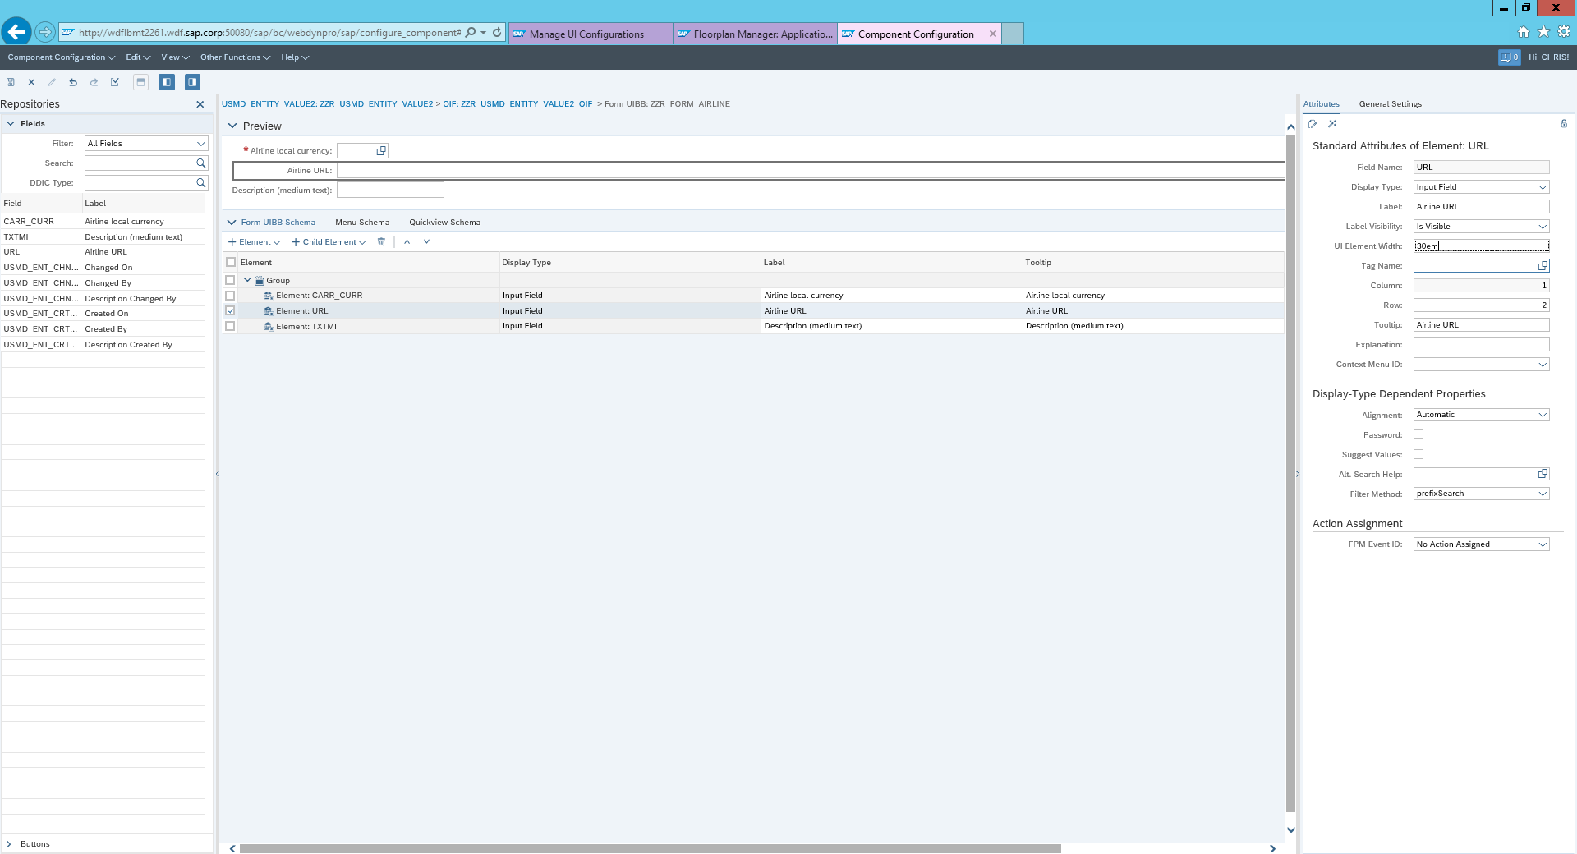

Now save and verify that the system does not detect any errors in the configuration

Close all Floor Plan Manager Windows

**Create the process Configuration**

Create the business activity

i) Start MDGIMG 🡪 General Settings 🡪 process modelling 🡪 Business activities 🡪 create business activities

ii) Select New Entries

iii) Add in the following details:

Bus. Acty: ZAXY

Description: ZA Create Airline

Data model: ZA

BO Type: Leave blank

iii) When prompted for workbench request select the one you created when setting up the data model

Create a Change Request

i) In IMG, navigate to General Settings → Process Modeling → Change Requests → Create Change Request Type.

ii) Choose new entries and enter your change request type:

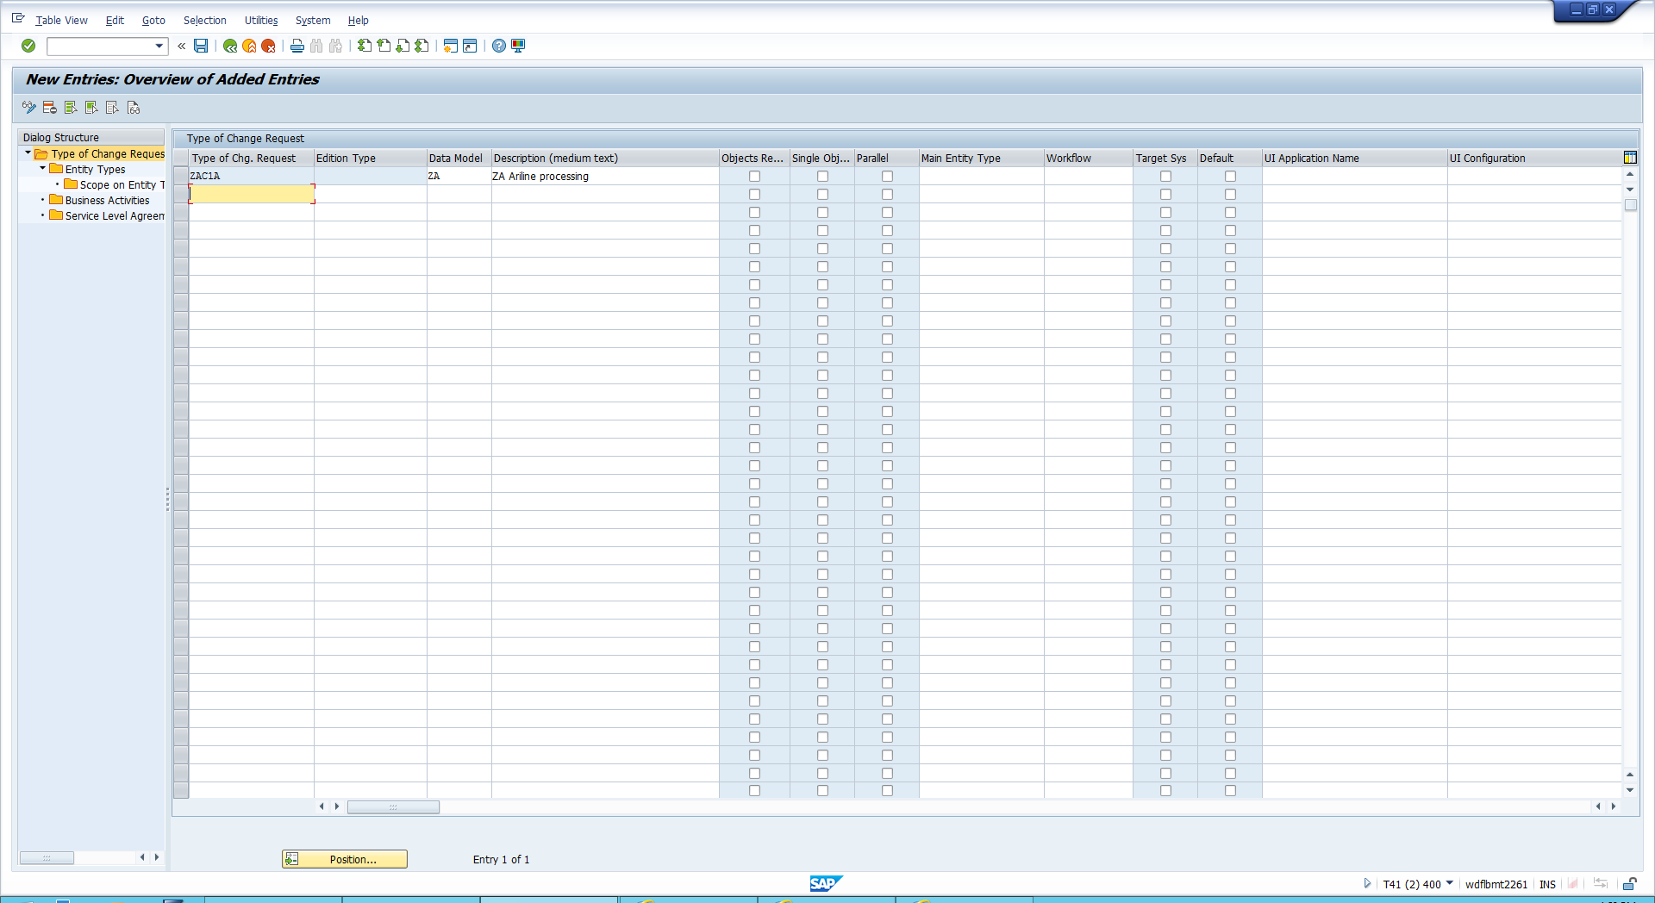

iii) Click save 🡪 Select the line you just created 🡪 double click entity types 🡪 Click new Entries 🡪 Enter entity type CARR 🡪 Choose enter and add your config ID for the UI configuration

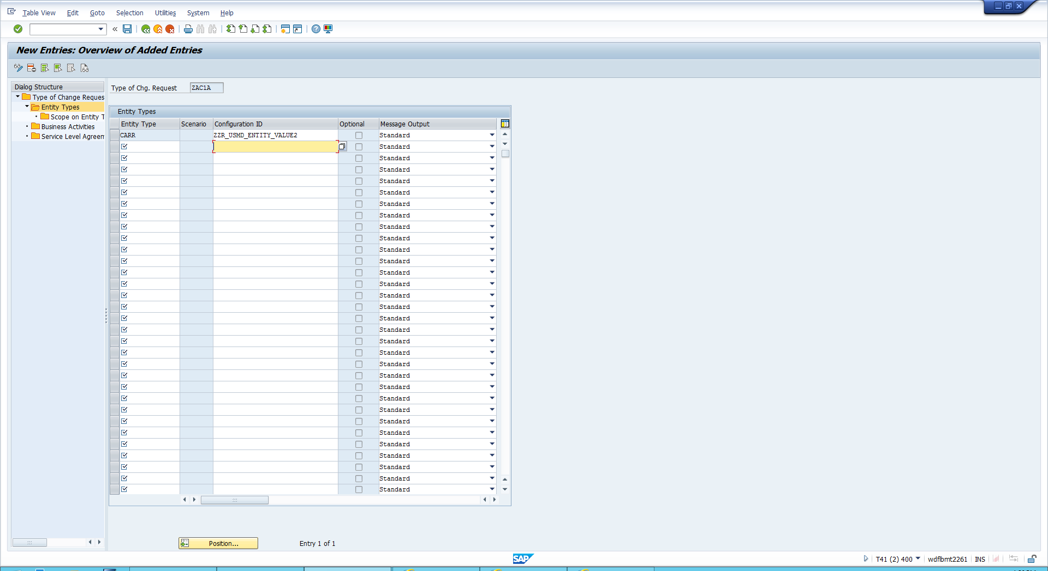

iv) Select your line and double tap business Activities 🡪 Click new Entries 🡪 Here enter the business activities you just created

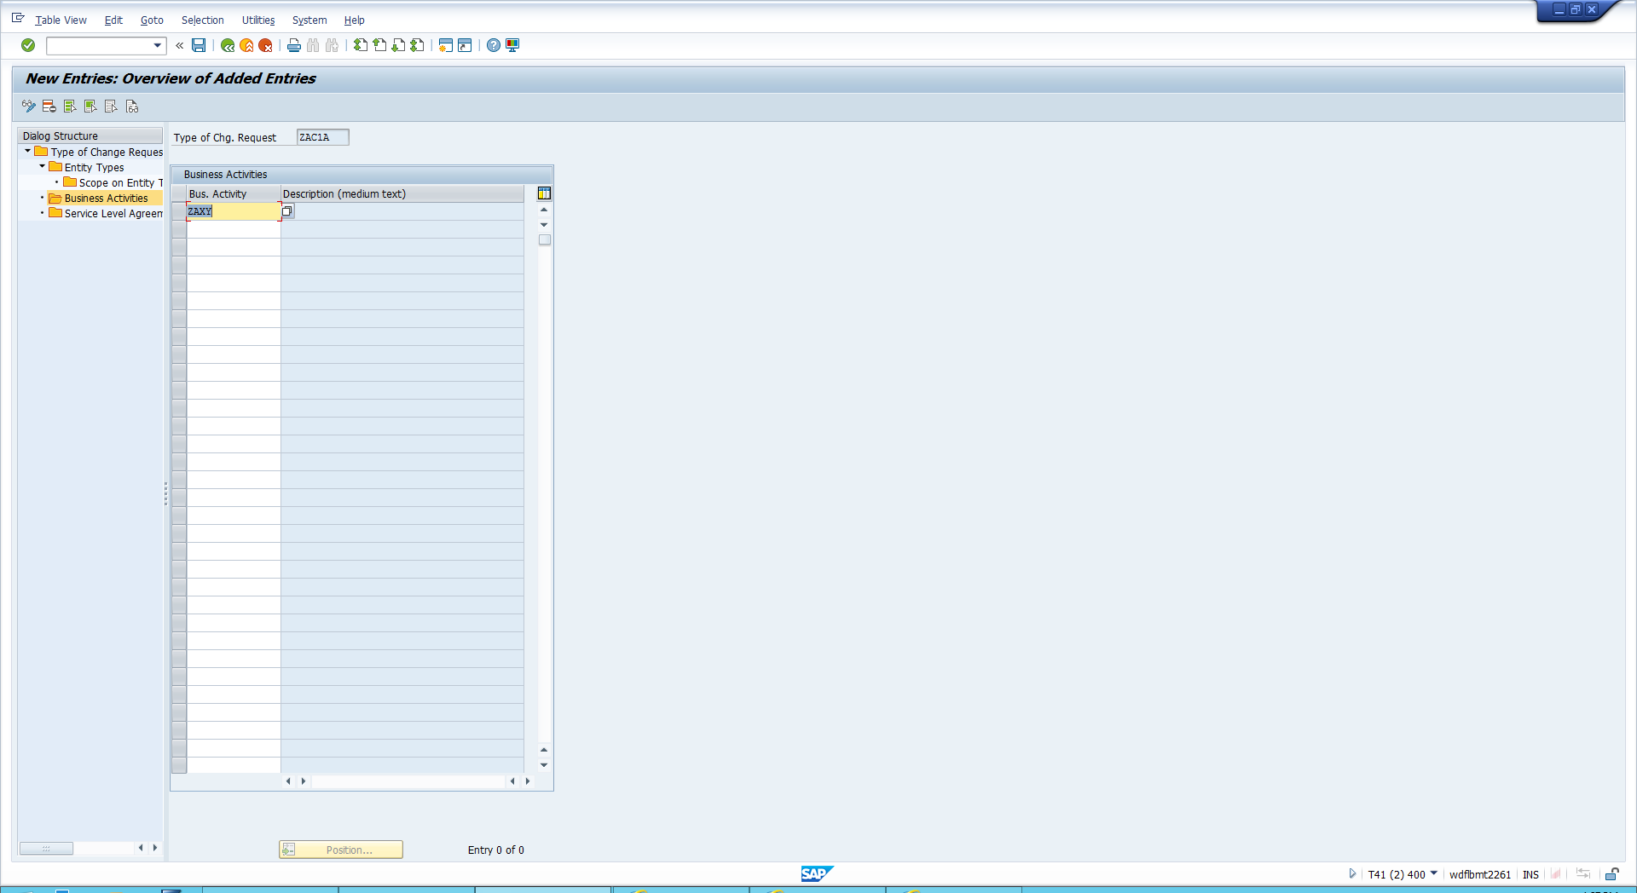

v) Save your data

Assigning a processor to workflow steps

i) In IMG, navigate to General Settings → Process Modeling → Workflow → Other MDG Workflows → Assign Processor to Workflow Step Number.

ii)Choose New Entries and enter your user id for your change request type for workflow steps 1 – 3.

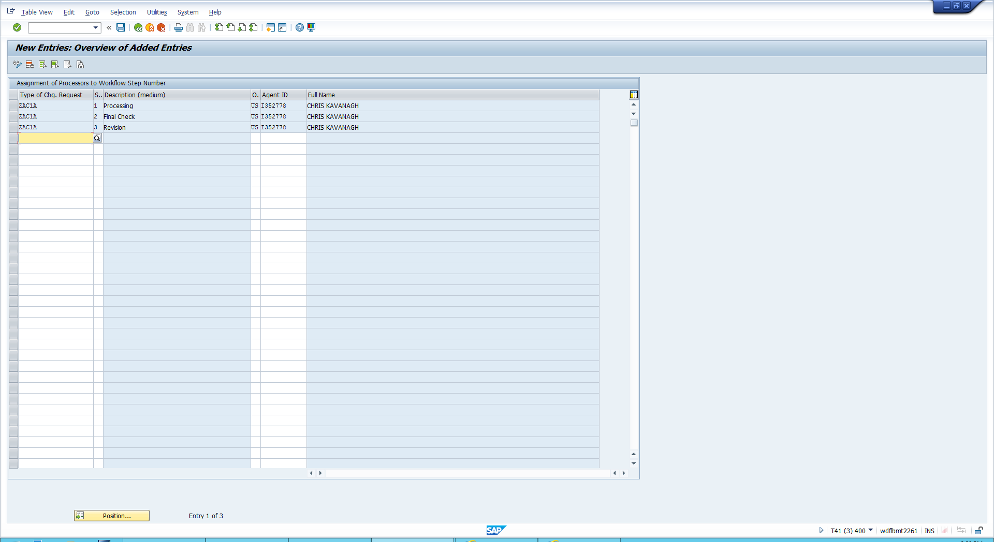

**Personalize your user with defaults**

i) Start the transaction su01 🡪 enter your user id and execute 🡪 Navigate to personalisation’s 🡪 Locate the object key R_FMDM_MODEL

ii) Double click the personalisation object SAP Master Data Governance, and enter your data model ZA as standard data model 🡪 Enter your UI configuration

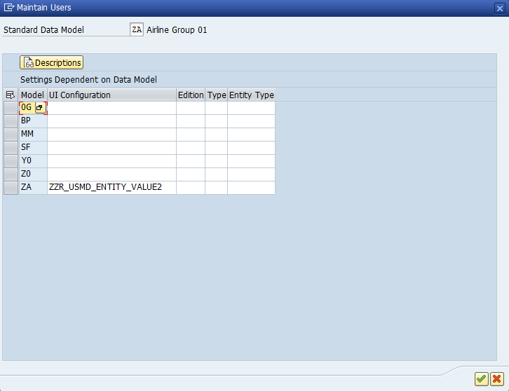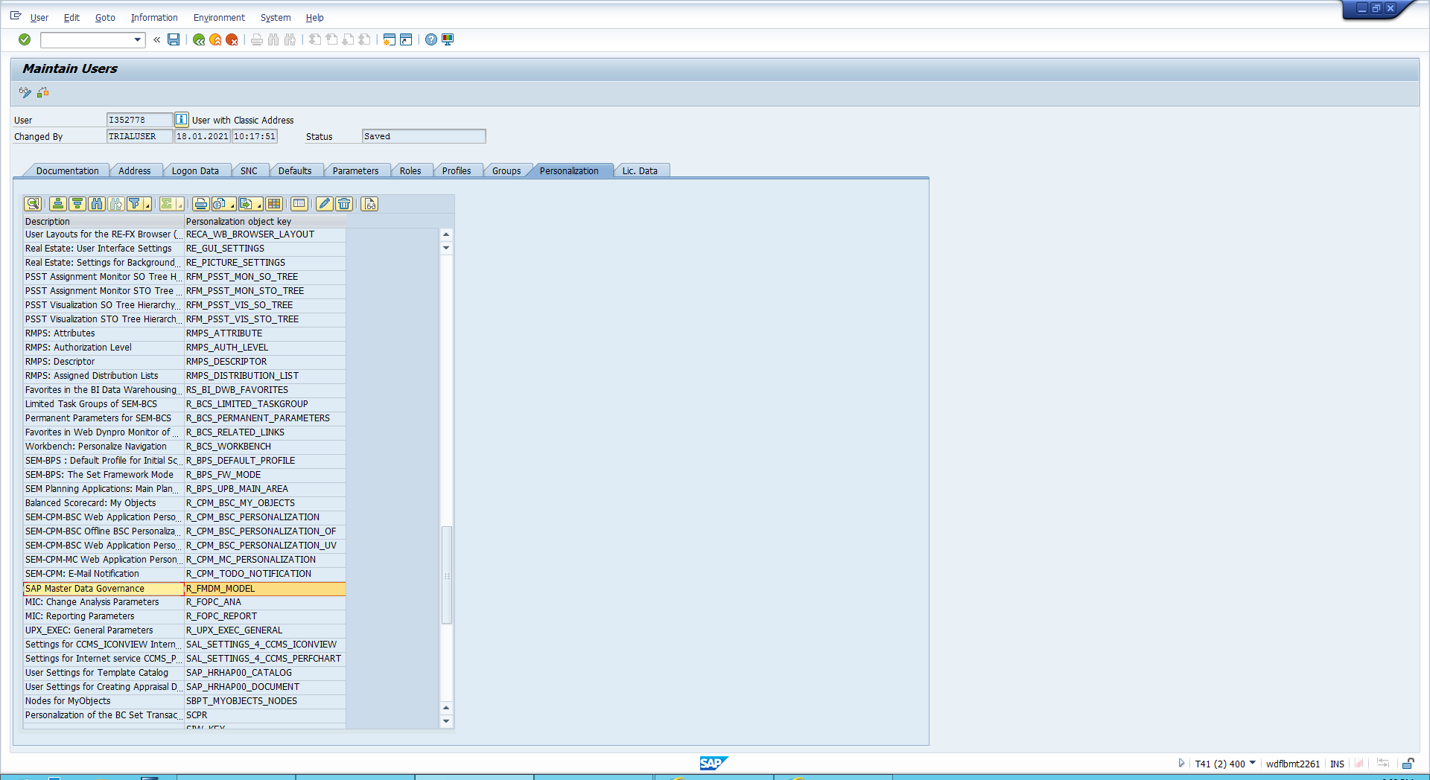

**Create the User Menu**

End users will access mdg from NWBC. To make that possible a role with an appropriate menu needs to be provided

i) Start Transaction PFGC

ii) Enter the name SAP_MDGX_MENU

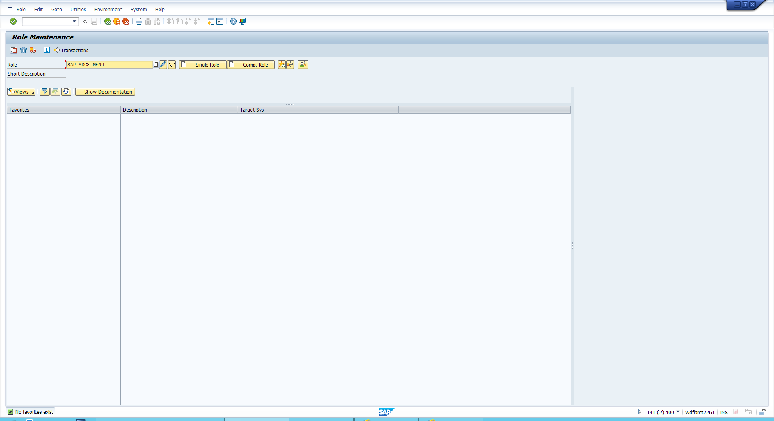

iii) Choose Copy and enter ZA_SAP_MDGX_MENU 🡪 click copy all

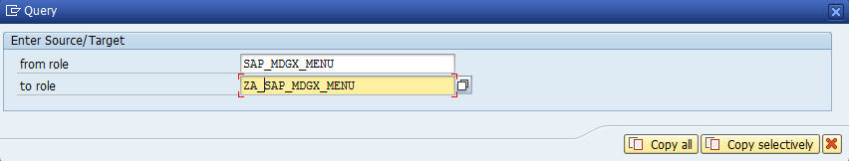

Iv) Click edit 🡪 Rename the description so you can find the role easier eg: ZR **** 🡪 Select the User Tab

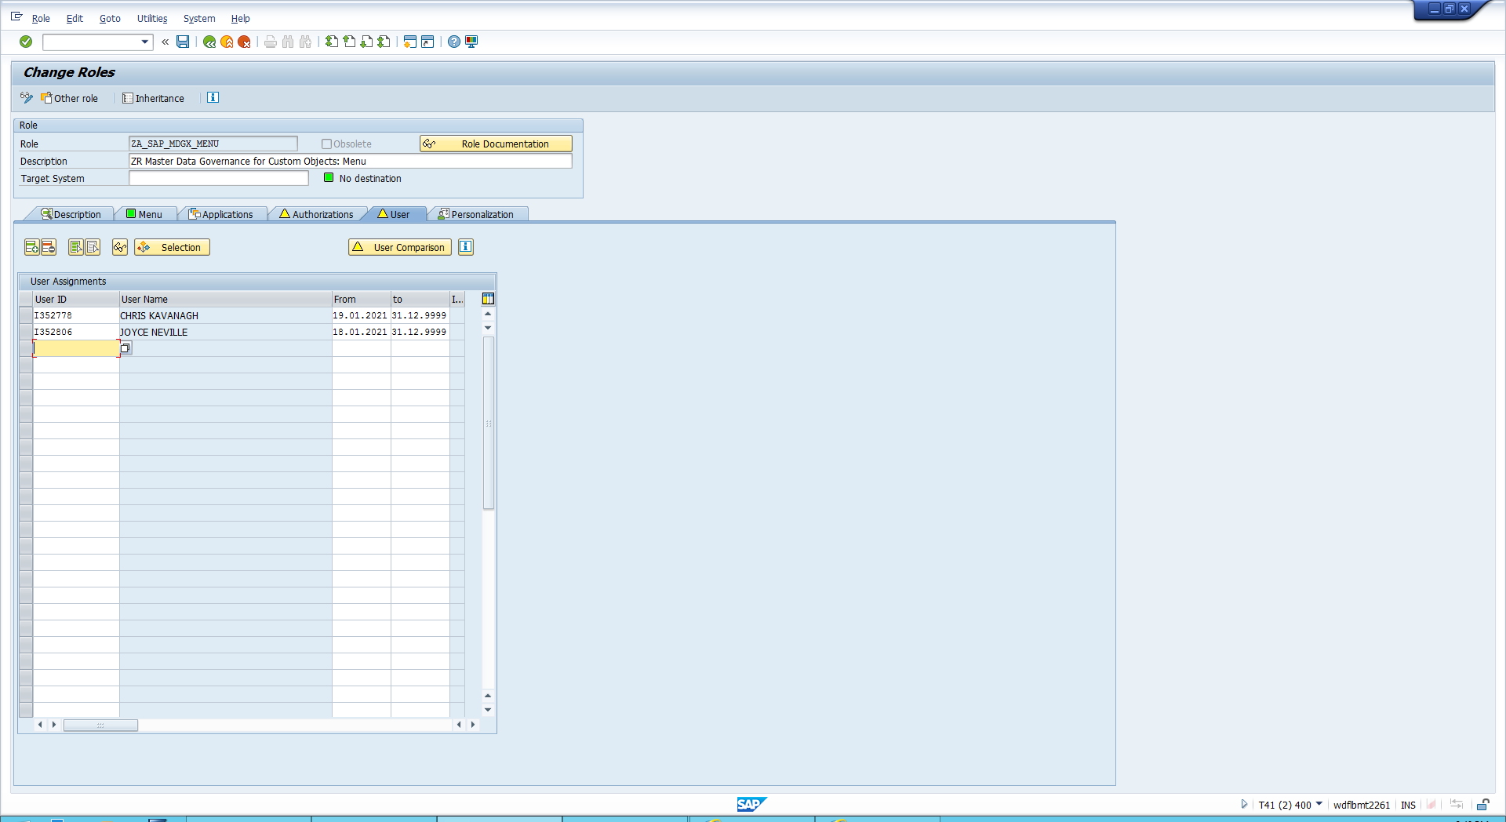

v) Remove all user but your own. (Otherwise other users will have the new menus offered as well

Create the folder for new entries

i)Select the Menu tab.

ii) Select the Master Data Governance for Custom Objects folder.

iii) Select the Create folder.

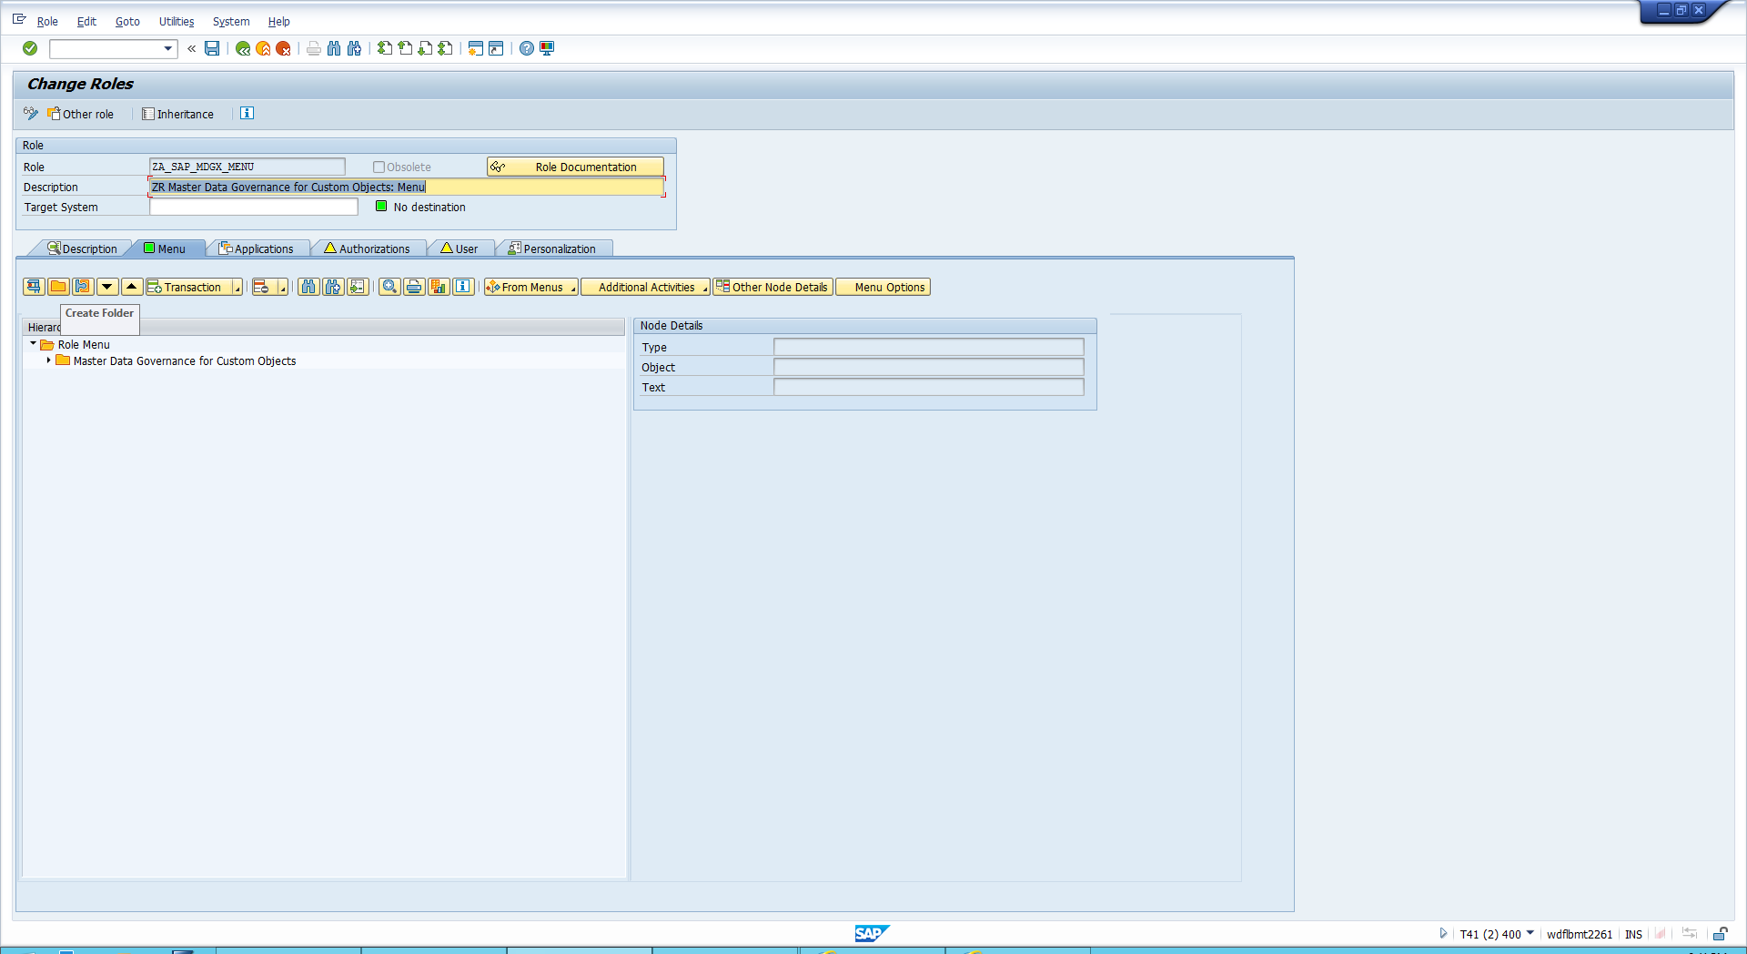

iv) Enter a name for the folder eg: ZA Airline Maintenance

Add Search Capability

i) Select the newly created folder 🡪 Choose Transaction 🡪 Add Web Dynpro Application

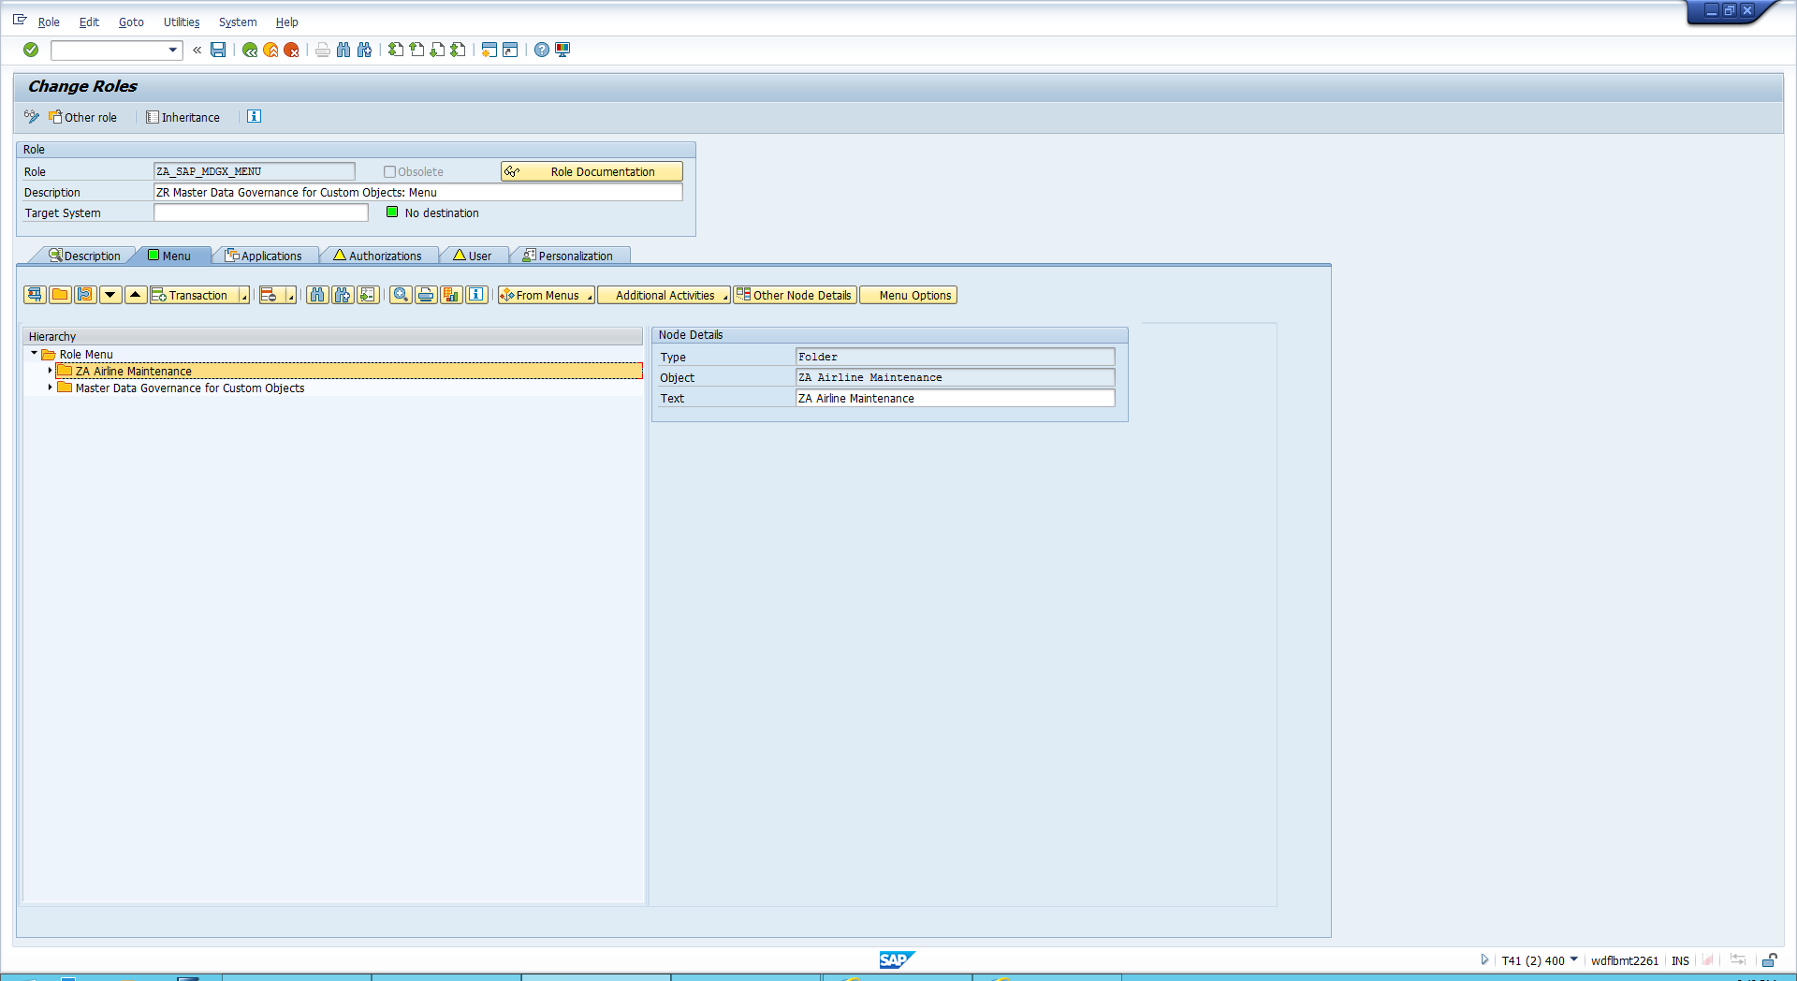

ii) As the name of the application, in the Web Dynpro Applicat. field, enter USMD_ENTITY_SEARCH.

iii) As the description of the menu entry, in the Description field, enter Search ZA Airline.

Iv) Enter parameter PROCESSwith the value of the business activity of your group: ##C1.

Repeat the steps of above

v) Add a application – Web Dynpro Application 🡪 Enter description Process ZA Airline 🡪 Enter the parameter Process followed by ZAXY 🡪 Enter parameter IS_CREQ_MODE with the value of your business activity ZAXY (Ignore values in screenshot below it is just an example)

